AMSIRS: A WEB-BASED INTEGRATED INSTITUTIONAL SYSTEM FOR ACCESS MONITORING, SAFETY INCIDENT REPORTING, AND STUDENT SUPPORT

A Thesis
Presented to the
School of Information Technology
Mapua Institute of Technology

In Partial Fulfillment
of the Requirements for the Degree
Bachelor of Science in Information Technology

by
Jermaine Dwayne Howard B. Chung
Kolby Jaynielle Luiz P. Hernandez
Axl Ross A. Santos

March 2026

RECOMMENDATION SHEET

This is to certify that I have supervised the preparation of and read the thesis proposal prepared by Jermaine Dwayne Howard B. Chung, Kolby Jaynielle Luiz P. Hernandez, and Axl Ross A. Santos entitled AMSIRS: A Web-Based Integrated Institutional System For Access Monitoring, Safety Incident Reporting, And Student Support and that the said paper has been submitted for final examination by the Oral Examination Committee.

Antonette D. Gabriel
Thesis Adviser

TABLE OF CONTENTS
TITLE PAGE i
APPROVAL SHEET ii
TABLE OF CONTENTS iii
LIST OF FIGURES v
Chapter 1 INTRODUCTION 1
1.1. Context of the Study 1
1.2. The Problem, Gap or Opportunity 4
1.3. Research Questions 5
1.4. Research Objectives 6
1.5. Significance of the Study 6
1.6. Scope and Limitations (or Delimitations) 7
1.7. Process Flows 10
1.8. Conceptual Framework 14
Chapter 2 REVIEW OF RELATED LITERATURE & STUDIES 16
2.1. Definition of Terms 16
2.2. Review on Related Published Studies 22
2.3. Review on Related Systems 49
2.4. Review Synthesis 56
Chapter 3 METHODOLOGY 61
3.1 Software Methodology 61
3.1.1 Requirement Analysis 61
3.1.2 System Design 62
3.1.3 Development 62
3.1.4 Testing 62
3.1.5 Deployment 63
3.1.6 Evaluation 63
3.2 Research Methodology 64
3.2.1 Research Design 64
3.2.2 Research Locale 64
3.2.3 Research Respondents 65
3.2.4 Research Instrument 66
3.2.5 Data Gathering Procedure 67
3.2.6 Samples and Sampling Techniques 67
3.2.7 Statistical Treatment 68
3.2.8 Technology Stack 69
3.2.9 Security & Privacy Measures 71
3.2.10 Face Recognition Module Testing and Evaluation 72
3.2.11 Use Case Diagram 73
3.2.12 Entity Relationship Diagram 76

LIST OF FIGURES
Figure 1. Existing Process Flow 11
Figure 2. Proposed Process Flow 13
Figure 3. Conceptual Framework 15
Figure 4. Interface of Online Student Support System 50
Figure 5. Interface of Automated Incident Reporting Management System 52
Figure 6. Interface of AttenFace for Students 53
Figure 7. Interface of AttenFace for Faculty Members 53
Figure 8. Interface of Secure School 54
Figure 9. Interface of Automated Attendance and Analytics System 55
Figure 10. V-Model (Verification and Validation Model) Visualization 64
Figure 11. Technology Stack Visualization 71
Figure 12. Use Case Diagram Visualization 75
Figure 13. Entity Relationship Diagram (ERD) of AMSIRS 76

Chapter 1
INTRODUCTION
This introductory chapter provides a foundational overview of the study. It is divided into eight parts, as follows: the Context of the Study, the Problem, Gap or Opportunity, the Research Questions, the Research Objectives, the Significance of the Study, the Scope and Delimitations, the Process Flows, and the Conceptual Framework.

Context of the Study
The contemporary academic environment is marked by increasing administrative complexity and a growing demand for institutional efficiency, a mandate closely aligned with the United Nations Sustainable Development Goal 4 (SDG 4), which advocates for inclusive and equitable quality education [1]. In response to these global expectations, universities worldwide are compelled to pursue systemic digital transformation initiatives that emphasize quality assurance, operational transparency, and real-time data accessibility. These reforms are essential to ensuring that academic institutions remain responsive to the evolving needs of students, faculty, and administrators in an increasingly data-driven educational landscape.

A primary information technology response to this transformation is the adoption of the Web-Based Integrated Institutional System for Access Monitoring, Safety Incident Reporting, and Student Support (AMSIRS) framework. Unlike traditional management systems that focus on finance or enrollment, an AMSIRS is a digital infrastructure designed to coordinate the "non-academic" pillars of student success—specifically physical safety, behavioral monitoring, and psychosocial support [2]. While this study operates within the broader domain of educational technology, it specifically addresses the urgent need for integration among three operational domains that are critical to student well-being but have historically functioned in isolation: Access Monitoring, safety incident reporting, and student support services.

Access Monitoring is redefined in modern research not merely as a compliance tool, but as a critical safety mechanism that utilizes biometric verification to ensure the physical accountability of learners within campus premises [3]. Complementing this, Student Support Services function as a "wraparound" intervention framework, providing necessary counseling and behavioral guidance to address socio-emotional factors that impact retention and institutional effectiveness [4]. Safety incident reporting is equally vital; as emphasized in recent "Safe School" frameworks, maintaining a secure environment requires structured, real-time mechanisms capable of capturing and responding to threats to protect the academic community [5].

Despite the global shift toward these integrated welfare technologies, current administrative practices at the local institutional level remain largely dependent on manual, fragmented, and legacy-based procedures. Attendance records are maintained in paper-based formats, incident reports are processed through isolated printed documentation, and student support data lacks a digital verification mechanism, rendering real-time monitoring and oversight unattainable. This reliance on manual processes leads to significant data fragmentation, operational delays, and increased vulnerability to human error. Consequently, administrators are constrained in their ability to access timely and accurate information, which impedes effective decision-making and limits the institution’s capacity to implement proactive interventions.

In light of these challenges, the present study is undertaken to bridge the gap between existing manual practices and contemporary digital welfare standards. It seeks to apply established information technology principles in the design and development of a Web-Based Integrated Institutional System for Access Monitoring, Safety Incident Reporting, and Student Support (AMSIRS) that consolidates access monitoring, student support services, and safety incident reporting into a centralized digital platform. Through this integration, the proposed system aims to enhance data accuracy, improve institutional coordination, and strengthen real-time monitoring capabilities, thereby promoting operational efficiency and supporting informed administrative decision-making within the academic institution.

The Problem, Gap or Opportunity
The existing administrative environment at Cavite National High School - Senior High School is faced with operational inefficiencies occasioned by its dependence on fragmented and manual systems. Access Monitoring, safety incident reporting, and student support services are all handled individually, often manually, and therefore cannot be consolidated to provide timely and accurate data.
The core issue is that such a dependency on manual operations creates a reactive rather than proactive environment. In the current setup, attendance logs and incident reports remain static records in filing cabinets or isolated spreadsheets. This creates a severe shortage of real-time actionable information for administrators and guidance counselors. Consequently, this leads to delays in identifying at-risk students, failure to recognize patterns of chronic absenteeism or behavioral issues early, and the inability to provide timely academic or emotional support. This inequality in systems leads to data silos, which limit comprehensive reporting and, consequently, hinder the institution's ability to intervene before a student drops out or faces severe disciplinary action.

The Research Gap
While current digital solutions and biometric technologies are highly effective in treating individual areas, they overwhelmingly operate independently. For instance, standalone facial recognition systems are successfully deployed in public transit for security and access control (Biometric Breakthroughs for Sustainable Travel [6]; AI-Based Security Surveillance Systems [7]), and recent innovations demonstrate the efficacy of biometrics in monitoring student logistics, such as tracking students boarding transport (Facial Recognition in Transportation System [8]). Similarly, specialized digital attendance applications in educational settings effectively capture student presence and notify parents (A Comprehensive Review on Smart Attendance System [9]; Smart Attendance System: An IoT-Enabled Concept [10]). Studies further indicate that digital attendance systems can positively influence student discipline and academic monitoring [11]. However, these solutions remain largely independent and do not support integrated intervention workflows. Modern system integration practices emphasize the importance of unified architectures and seamless data exchange among interconnected systems to reduce operational silos and improve organizational efficiency [14][15]. The continued reliance on disconnected platforms often results in fragmented information and limited institutional visibility, hindering timely decision-making and proactive student support [16].
However, these solutions function strictly as physical trackers or gatekeepers. The most critical gap remains the successful integration of these automated "Risk Indicators" with institutional "Support Mechanisms." Existing literature frequently focuses on data collection—such as securing an entry point, tracking a student on a bus, or recording an absence—but fails to address the workflow of intervention (e.g., automatically alerting Student Support to assist the student). This research fills that gap by proposing a system where data does not just sit in an isolated database but actively triggers support protocols, thereby minimizing data silos and creating an environment of comprehensive student welfare and accountability.
This research, therefore, presents an opportunity to establish a Web-Based Integrated Institutional System for Access Monitoring, Safety Incident Reporting, and Student Support (AMSIRS) that uses unified data architecture to transform school administration from a passive record-keeper into an active support system.

Research Questions
This study aims to address the following central research inquiry:
How can the fragmented operational domains of Access Monitoring, Safety Incident Reporting, and Student Support Services be integrated into a unified Web-Based Integrated Institutional System for Access Monitoring, Safety Incident Reporting, and Student Support (AMSIRS) to facilitate real-time data compatibility and proactive student intervention?

Research Objectives
The general objective of this study is to design and develop AMSIRS for Access Monitoring, Safety Incident Reporting, and Student Support that unifies fragmented campus operations into a single, proactive digital platform. Specifically, this study aims to achieve the following:
- To evaluate the efficiency of a unified data architecture in reducing information silos and improving real-time data retrieval speeds between independent attendance, safety, and student support databases.
- To assess the accuracy and reliability of the system’s automated intervention logic in correctly correlating attendance anomalies (via facial recognition data) and safety incidents to trigger timely, proactive alerts for the Student Support Office.
- To measure the usability, functionality, and operational effectiveness of the integrated role-based web portal among key institutional stakeholders (administrators, faculty, and security personnel) utilizing the System Usability Scale (SUS) and system-generated performance metrics.
Together, these three objectives directly address the central research question by providing measurable indicators of how effectively AMSIRS integrates its operational domains into a unified, proactive digital platform.

Significance of the Study
The research is expected to have a significant impact in the area of information technology, as it provides a documented model for consolidating disparate systems on campuses, thereby addressing the issues of administrative fragmentation [12]. The system model, along with its architecture and data integration mechanism, will serve as a reference base for computer scientists and IT professionals developing enterprise resource planning solutions for academic institutions. The practical importance of this research will likely apply to several key institutional stakeholders. For university administrators, the system will enable the centralization of data management, allowing the institution to run on a single version of the truth [1]. Such transparency enhances the creation of timely and accurate reports, facilitates compliance reporting, and enables informed decisions based on data for resource allocation and student success strategies [13]. In the case of Faculty Members and Teachers, the system will automate time-consuming administrative tasks, especially check attendance and record of incidents, which will ease the workload assigned to the teachers and enable them to concentrate on teaching [13]. To Students and Parents, the integrated system adds value to the experience by simplifying administrative processes. Portals are user-friendly to students, and optional real-time attendance and schedule records of children allow parents more time to be more responsible [4]. In the case of Guards and Security Personnel, the system offers a user-friendly interface to help quickly review student schedules and permissions to exit, which enables timely security decisions and improves the overall safety of the campus.

Scope and Delimitations
The primary focus of this research is the design, development, and implementation of a centralized Web-Based Integrated Institutional System for Access Monitoring, Safety Incident Reporting, and Student Support (AMSIRS), specifically engineered to modernize the management of campus safety and student welfare. The core functionality of the system is anchored on the Incident Reporting Module, which serves as the central digital repository for documenting, organizing, and retrieving records of safety-related events and behavioral infractions within the school premises. This module is designed to streamline the currently fragmented manual reporting procedures used by security personnel and faculty, ensuring that every incident—ranging from minor behavioral misconduct to significant safety concerns—is accurately logged with timestamps, descriptions, and involved parties for future reference and administrative review.
To provide the necessary context and data validation for incident reporting, the system integrates a biometric Access Monitoring Module utilizing Face Recognition technology. The scope of this attendance feature is strictly limited to the monitoring of student ingress and egress at the main campus entry and exit points. By deploying face recognition at these specific locations, the system automatically generates a "Time-in" and "Time-out" log for each student. The primary purpose of this data is to corroborate incident reports by verifying the physical presence of a student on campus at the time a reported event occurred, thereby eliminating reliance on manual logbooks or proxy attendance.
Furthermore, the system includes a Student Support System which functions as the data-driven intervention arm of the platform. This module is specifically designed to aid the Guidance Office by providing a consolidated view of a student’s behavioral history and attendance record. By accessing the data aggregated from the Incident Reporting and Attendance modules, the Student Support System allows authorized counselors to identify patterns of misconduct or truancy. This integration facilitates the welfare of the student body by enabling administrators to move from reactive punishment to proactive counseling and support, ensuring that interventions are based on accurate, historical data rather than isolated reports.
Despite the system’s integrated nature, specific technical and functional boundaries are established to ensure the feasibility of the study. The Face Recognition implementation is delimited to a software-based prototype utilizing standard high-definition web cameras or IP cameras, rather than industrial-grade biometric turnstiles or proprietary hardware sensors. Consequently, the accuracy and speed of the facial recognition feature are subject to the limitations of the camera hardware and the environmental lighting conditions of the testing area. The system does not claim to function with 100% accuracy in low-light environments or with non-cooperative subjects (e.g., face coverings or extreme angles).
Functionally, the Incident Reporting Module is designed as a documentation and workflow management tool, not an automated surveillance system. The study delimits the system from using Artificial Intelligence (AI) for video analytics or action recognition; it does not automatically detect fights, vandalism, or accidents through CCTV feeds. All incident data must be manually input into the system by authorized personnel (security or faculty) after an event is observed. The system serves to record the aftermath and details of an incident, rather than acting as a real-time emergency alarm system for immediate police or medical dispatch.
Additionally, the scope of location tracking is strictly limited to the school gates. The system does not utilize GPS, RFID, or Bluetooth beacons to track the real-time location of students inside the campus (e.g., specific classrooms, cafeteria, or restrooms). The "presence" of a student is defined solely by their entry at the main gate and is assumed to continue until their exit is logged. Finally, the system focuses on internal campus administration and does not integrate with external databases, such as national police records or government educational databases, in compliance with the Data Privacy Act of 2012 regarding the handling of sensitive information of minors.

Process Flows
Existing Process Flow
The existing process flow for the institution of Cavite National High School – Senior High School relies on highly fragmented, manual procedures across three primary domains: Access Monitoring, safety incident reporting, and student support. In the attendance workflow, teachers verbally roll call and record data on paper, which is later submitted to administrators for manual encoding; consequently, comprehensive attendance reports are typically only generated at the end of the academic term. Similarly, the safety incident process begins with a student reporting to security, followed by the submission of physical documents to the central office where data is manually encoded, investigated, and ultimately filed away in hard-copy format. The student support subsystem operates in complete isolation, initiated by a teacher's verbal or paper-based referral. This requires guidance counselors to manually retrieve physical student records, schedule counseling sessions without automated tools, and store sensitive session notes in isolated filing cabinets. Collectively, these disparate workflows are hindered by their foundational process rules, a reliance on manual data encoding, delayed document submissions, and paper-based storage. As a result, this architecture completely lacks real-time data access and remains highly vulnerable to human transcription errors, informational silos, and physical risks such as document loss or environmental damage, underscoring the operational necessity for the Web-Based Integrated Institutional System for Access Monitoring, Safety Incident Reporting, and Student Support (AMSIRS). A visualization of the process flow is shown in the figure below.
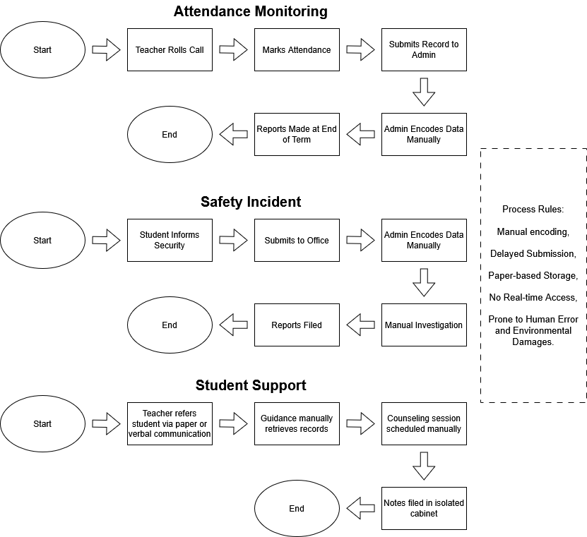
Figure 1. Existing Process Flow
Proposed Process Flow
The proposed process illustrates the operational architecture of a Web-Based Integrated Institutional System for Access Monitoring, Safety Incident Reporting, and Student Support (AMSIRS), which transitions the institution from fragmented, manual record-keeping to a centralized, proactive digital framework. The workflow initiates at the Data Collection tier, utilizing two primary inputs, student attendance is automatically captured via face recognition cameras at campus entry and exit points to generate real-time logs, while security personnel and faculty digitally record safety incidents directly into the system’s web portal. Unlike the legacy system, these distinct data streams immediately converge into the AMSIRS Core System, a centralized database that minimizes the usage of departmental data silos. Within this core architecture, automated system logic continuously cross-references a student’s attendance patterns with their incident history. If predefined risk indicators are met—such as a pattern of truancy combined with a behavioral infraction—the system automatically generates a real-time alert directed to the Student Support module. Upon receiving this notification, guidance counselors can access a unified dashboard that visualizes the student’s holistic academic and behavioral profile, empowering them to initiate immediate, proactive counseling interventions rather than relying on delayed manual referrals. Finally, the counselor securely logs the session notes and resolutions back into the central portal. This creates a continuous, data-driven feedback loop that enriches the student’s centralized record, ensuring that all future administrative and support decisions are governed by the system's new process rules of automated data capture, real-time synchronization, and proactive intervention. A visualization of the proposed process flow is shown below.
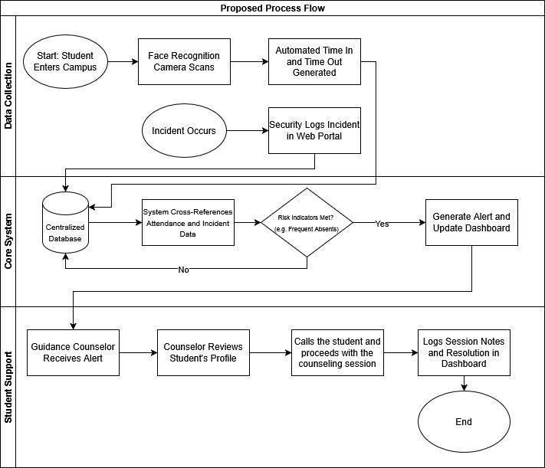
Figure 2. Proposed Process Flow

Conceptual Framework
The conceptual framework of this study is anchored on the Input-Process-Output (IPO) model, which systematically outlines the developmental lifecycle and functional architecture of the Web-Based Integrated Institutional System for Access Monitoring, Safety Incident Reporting, and Student Support (AMSIRS). The Input phase establishes the foundational prerequisites for the project, encompassing the analytical requirements such as hardware and software specifications, stakeholder requirements, and an assessment of existing manual workflows alongside the primary system data entities, which include biometric facial data, student academic profiles, and safety incident logs. These inputs are subsequently channeled into the Process phase, which represents both the software engineering methodology and the system's operational mechanics. Methodologically, this phase is governed by the V-Model (Verification and Validation Model) approach to ensure structured development. Operationally, it involves the system's core algorithmic functions, such as facial recognition for attendance logging, centralized database synchronization, and the execution of automated intervention logic, culminating in a rigorous usability evaluation using the System Usability Scale (SUS). Finally, the Output phase represents the ultimate deliverables of the study: a fully functional, role-based AMSIRS Web Portal. The strategic institutional outcomes of this deployed system directly address the research objectives by minimizing the usage of departmental data silos, delivering real-time administrative dashboards, and facilitating a proactive, data-driven approach to student welfare and campus safety. A visualization of the conceptual framework is shown below.
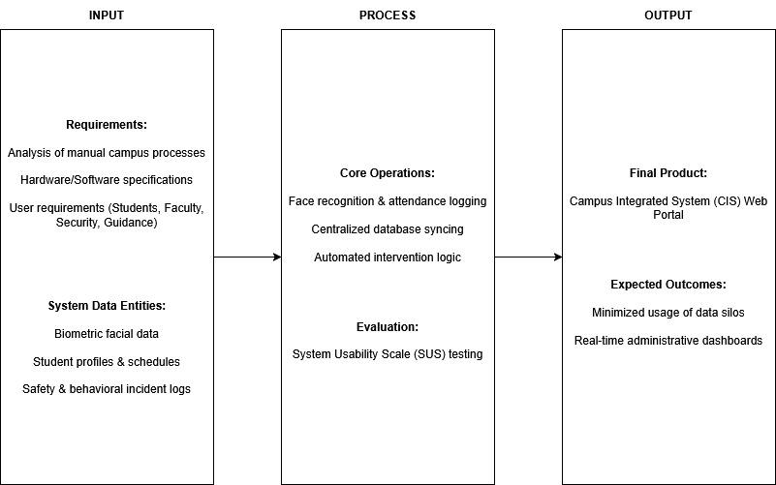
Figure 3. Conceptual Framework

Chapter 2

REVIEW OF RELATED LITERATURE AND SYSTEMS

Definition of Terms
Biometrics
Biometrics is an area that leverages unique physiological characteristics, such as facial features, for identification and authentication purposes. Within the proposed AMSIRS, this area emphasizes automating Access Monitoring by capturing and analyzing facial data to verify student or staff presence, thereby reducing manual errors and proxy attendance issues. Key components include image acquisition (via cameras or video streams), preprocessing (normalizing images for lighting and orientation), feature extraction (identifying key facial landmarks), matching algorithms (comparing extracted features against a database), database management (storing enrolled facial data and attendance records), and reporting modules (generating attendance logs in formats like Excel or integrated dashboards). Additional elements may involve machine learning integration for enhanced accuracy under varying conditions (e.g., illumination, head movements) and security protocols to prevent unauthorized access [17][18].

Face Recognition
Face recognition is a biometric technology that utilizes algorithms to detect, analyze, and verify human faces from digital images or video frames, often by extracting unique facial features such as the eyes, nose, and mouth for comparison against a stored database. This process typically involves stages like face detection (locating faces in an image), feature extraction (identifying key landmarks), and matching (comparing against known profiles using methods like Local Binary Pattern Histograms or Haar cascades). It is important to the field of computer vision and security systems because it enables automated, contactless identification, reducing human error, enhancing efficiency in high-volume environments, and supporting applications in surveillance, access control, and attendance tracking, particularly in Industry 4.0 contexts where real-time processing is critical [19].
Incident Reporting
Incident reporting refers to the systematic process of documenting and notifying authorities about events such as crimes, public disturbances, ordinance violations, or emergencies through digital platforms, often incorporating features like GPS location tracking, multimedia attachments (e.g., photos), and real-time forwarding to responders for validation and action. This can be facilitated via mobile applications that classify incidents, allow user authentication, and generate statistical reports for analysis. It is important to the field of public safety and informatics visualization because it promotes community collaboration, improves response times by providing verifiable evidence, and aids in data-driven policy-making to prevent future occurrences, especially in urban or institutional settings where underreporting due to fear or inefficiency is common [20].

Data Analytics and Reporting
Data analytics and reporting are the systematic processes of analyzing raw data to extract useful insights and presenting those findings in structured formats for decision-making. In the framework of the proposed AMSIRS, it helps administrators analyze patterns and provide reports that promote transparency, efficiency, and response. Data collection and integration (gathering attendance logs, incident records, and organizational data), data cleaning and preprocessing (removing errors, formatting, and standardization), quantitative analysis (descriptive and inferential statistics), qualitative analysis (coding narratives such as safety reports or student feedback), predictive analytics (forecasting trends like absenteeism or safety risks), and reporting modules (dashboards, charts and summaries for stakeholders). Additional components could include visualization tools, machine learning models for predictive insights, and safe storage to ensure data integrity [22][23].

School Management System
A Campus Information System, or School Management System, is an integrated platform that unifies academic and administrative operations in an educational institution. It streamlines processes such as Access Monitoring, incident reporting, organizational management, and academic record keeping. By centralizing these tasks, institutions improve efficiency, accessibility, and communication among students, faculty, and administrators. Campus informatization provides a one-stop platform that enhances institutional management and service delivery [23], while the successful development of an e-School System in the Philippines simplified institutional workflows and improved data management [24].

Integrated System
Integrated system is characterized as a coherent digital framework that integrates fragmented campus operations, including attendance tracking, incident reporting, and organization management, into one system via the adoption of technology, including AI, databases, APIs to guarantee a high level of data interoperability, scalability and a user-friendly information access. Under the context of the suggested AMSIRS, the system streamlines operations centrally, eliminates repetitions, and provides forecasting opportunities hence improving safety, efficiency, and academic responsibility across the school. The essential features are centralized storage and retrieval (unified databases), modules connectivity (AI/ML applications), user authentication (single sign-on and role-based access), real-time analytics (dashboards to track trends), remote access and scalability (cloud architecture) and adaptive features (such as risk prediction). It can also implement IoT to monitor with sensors and institution-specific customization tools [25].

Student Support System
A Student Support System (SSS) in an in-person educational setting is a structured, school-based framework that provides guidance, counseling, and behavioral intervention services to address the academic, social, and emotional needs of students. It operates as the institution's proactive welfare mechanism, enabling guidance counselors and school administrators to monitor at-risk students, conduct counseling sessions, and document intervention outcomes systematically. In a digitally integrated implementation, the SSS consolidates a student's behavioral history, attendance records, and incident data into a centralized platform, enabling data-driven decision-making and timely delivery of support. This approach shifts institutional practice from reactive disciplinary action to proactive, evidence-based student welfare management, directly supporting student retention and well-being.

Database Management System
Database Management Systems (DBMS) is one of the key aspects of information technology. It involves designing, developing, and managing software systems that facilitate the practical storage and organization of data and their retrieval and management. DBMS is the core of the proposed AMSIRS. It helps to centralize information in the proposed system based on attendance logs, safety incident reports, and organizational records, and store them in structured databases. It provides consistency, integrity, and data security by providing the following features: relational schema, data normalization, indexing, transaction management, and access control. DBMS is also scalable and concurrent by allowing several users (students, staff, and administrators) to interact with the system without conflicting with the data. The field is essential as it will enable the performance of credible data-driven operations, ease the maintenance of the system, and promote analytical modules such as dashboards and reports [27].

Enterprise Resource Planning
The paper creates a roadmap to deploy an Enterprise Resource Planning (ERP) system that best fits the needs of the state universities in the Philippines, and as a means of overcoming the problems that are brought about by incomplete and fragmented information systems. The study establishes the critical success factors based on the Delphi technique and allocates weight of importance based on the Principal Component Analysis based on the data obtained in several universities. The major results are that executive leadership that is strong, ICT best practices, socio-organizational variables including awareness of the ERP benefits and staff engagement are key to readiness and successful implementation. The framework suggests a readiness measurement instrument to assist universities examine their infrastructure, administration, and human strength prior to their promise to ERP implementation. In the end, the framework is provided as a guide to assist universities to enhance operational efficiency, upgrade ICT infrastructure, improve technologies and provide policy decisions. [28].

Review on Related Published Studies
Design and Implementation of a Student Attendance Management System based on Springboot and Vue Technology [29]
The study aims to create an effective, automated student attendance management system based on Spring Boot, Vue.js, and MySQL to improve the efficiency of the management of educational institutions and alleviate the load on the teachers with administrative tasks. The research question is based on the investigation of the possibility of modern web technologies to automatize the processes of attendance in order to reduce the number of mistakes and enhance data analysis. The scope is narrowed down to educational systems, such as user management, student and teacher management, class/course management, attendance records, leave management, statistical reports, and system settings. The approach will use a modular architecture using Spring Boot to develop the backend, Vue.js to develop interactive interfaces, and MySQL to operate and store data, including elaborate implementation of API services and interacting elements. The results and conclusion indicate that the system was successful in offering correct, prompt Access Monitoring and reports further informing the understanding of the practical uses of these technologies and overcoming the drawbacks of traditional manual methods such as time usage and inaccuracies.

The values of this literature to the discipline of educational technology are the demonstration of a feasible combination of back-end and front-end infrastructure used in the attendance system, the encouragement of the digitalization of schools to improve their performances and decision-making with the help of data analytics. It develops the field by showing that it is possible to develop scalable, user-friendly applications without being expensive, using open-source tools. The strengths in general are a thorough development process recorded in code examples and architecture description that shows the benefits of modular design in maintainability and extensibility well. The areas that have been done well are the focus on practical usefulness like automated reports and active queries, which directly address the common pain points in attendance management. The general weaknesses include the lack of empirical testing or performance measure, use of descriptive results instead of quantitative validation and what is not done is user appraisal or comparison with the existing systems. It may lack scalability tests on large numbers of users or mobile device compatibility and what has to be done is to put the field tests and measure scales such as response time and errors to confirm reliability.

A Review Paper on Advanced Attendance and Monitoring Systems [30]
The paper will aim to review and discuss innovative approaches to attendance and monitoring of employees with special emphasis on fingerprint, iris recognition, RFID, and GPS to enhance accuracy and efficiency as compared to manual approaches. The research question is based on the question of what technology will be the most effective in resolving such problems as time consumption, mistakes, and fraud when tracking attendance. The context is limited to organizational situations, especially those organizations that employ field or office workers, to compare the biometric and the non-biometric methods. The methodology is a literature review of the benefits, drawbacks, cost, complexity and besides and limitations of previous works coupled with a comparison table of systems. The conclusion and findings indicate that biometric, such as fingerprint and iris are more precise but costly, whereas RFID and GPS are cheap concerning certain applications; the paper further stresses the choice of systems depending on the needs of the company to minimize human errors and promote monitoring.

The contributions of the literature on the area of attendance systems are that it offers a comparative analysis of various technologies and aids organizations to select the right solution to workforce management and minimize inefficiencies in manual work. It adds value to the field, as it emphasizes such practical implications as remote employee tracking in real-time and contributes to making informed decisions in HR technology. The advantages in general are the comparison table and discussion of pros/cons which are in depth and summarize various methods and their application. This is a review of biometric versus non biometric options, what is suitable in various localities as office work or field work. The main weaknesses are the absence of original data or case studies, the use of the secondary sources only and what has not been done is the empirical testing or quantitative measures of the performance of the system. It may lack new-fangled technologies such as the introduction of AI or privacy issues, and the solution is to add recent advancements and do primary research to confirm it.

IoT Based Smart Attendance System Using RFID: A Systematic Literature Review [31]
The study aims at systematically reviewing 21 articles on IoT-based attendance systems with RFID in order to determine the trends, challenges, and advantages of this technology in learning and organizational environments. The research question examines the role of RFID-IoT systems in solving the challenge of manual attendance, wastage of time, proxies and loss of data. The scope of the present research is on RFID in education, searching the publications in databases such as Google Scholar till 2023, and quality of the publications is evaluated. The methodology is a systematic review process, which involves search of 1450 papers, selection in terms of inclusion/ exclusion criteria, quality scoring and development of taxonomy of challenges and benefits. Its findings and conclusion suggest that RFID-IoT systems are accurate, efficient, and scalable but have security, cost, and technical challenges; they provide evidence-based practices to improve the smart learning process in the future.

The literature contributions to this field of study in the education sector relates to the synthesis of trends in 21 studies, presenting a taxonomy of advantages such as time-saving and issues such as security vulnerabilities to give the institutions a direction on which reliable methods of attendance are developed. It is moving the region forward, with highlighting the superiority of RFID in data accuracy and real-time processing, it opens the way to smart campuses. The strengths are in general the rigorous selection and quality evaluation that has been effective in select high-value studies and is an evidence-based analysis. It has been done as a comprehensive review with bibliography with a particular emphasis on environmental benefits and flexibility. The weaknesses in general include the possibility of bias in database selection, as well as being restricted to 21 papers, and what has not been conducted is original system development or quantitative meta-analysis. It may not have detailed case studies or non-educational uses and the thing that should be done is to expand to additional databases and add in primary experiments to validate.

Development of Access Monitoring System with Artificial Intelligence Optimization in Cloud [32]
The study aims at creating a biometric attendance system that is cloud-optimized with AI to displace both manual systems to increase precision and efficiency in academics. The research question will be the way fingerprint biometrics and AI can minimize mistakes in tracking attendance. The educational settings are in scope, and the systems based on fingerprints and cloud storage and SMS notification are considered. The methodology entails five activities, namely literature review, system design using Arduino and Wi-Fi module, implementation, testing using 30 respondents, and evaluation using questionnaires. Its results and conclusion demonstrate good usability (86.6% of positive feedbacks) and efficiency because the system minimized mistakes and provided real-time parental notifications, which were better than traditional approaches.

The works of this literature within the sphere of biometric systems involve the suggestion of an AI-optimized cloud data-based attendance system, as well as an increase of reliability and inclusion of notifications to stakeholders. It develops the field by showing low cost hardware such as Arduino in practical implementation in schools. Their integrative capacity and user testing, which involve questionnaires, is the overall strength and was successful in validating usability and efficiency. It has been completed with a complete development cycle with performance measures, addressing security and convenience. The weaknesses are mainly limited sample size (30 respondents) and not being compared against other biometrics, and what is not done is the scalability testing of large institutions. It may have lacked privacy analysis or integrated mobile apps and the only thing to do is to scale the testing and integrate advanced AI detecting fraud.

An Embedded Intelligent System for Access Monitoring [33]
The aims of the given study are to suggest an embedded smart system to monitor attendance in classes with the help of facial recognition on Raspberry Pi and to send the lists to a remote computer. The research question addresses the problem of how facial recognition models can be modified to operate on resource-limited devices such as Raspberry Pi, without the performance being impaired. It targets educational classrooms and solves such issues as resource scarcity, fluctuations in lighting, and real-time processing. The approach will include the implementation of optimized deep learning models (Yunet, SFace) on Raspberry Pi with Pi camera, a web application to manage it, and testing under the conditions of various scenarios. These results and conclusion show that there is feasibility with up to 100 percent accuracy in the best conditions but with 17-25 percent in poor angles (17-25 percent) it is advisable to make further optimizations to control the resources and image quality.

The inputs that the literature has made in the embedded AI field are the use of edge computing to detect attendance through facial recognition, model optimization to achieve better performance in low-power devices to improve security and efficiency. It drives the field forward by incorporating hardware-software solutions to real-world educational use. The testing and the model comparisons in a scenario are the overall strengths, well demonstrating practical performance measures such as an error rate and the accuracy. The adaptation of pre-trained models and user-friendly web applications has been carried out, covering the effects of viewing angles. The general limitations (consist of hardware and altogether diligent to no massive use) are confined to any particular hardware and what has not been accomplished is integration with other biometrics or privacy tests. It may lack the capability to scale to multi-users or extensions to mobile, and the thing required is to come up with a super-resolution of cameras and test it in various environments.

Development and Evaluation of an Attendance Tracking System Using Smartphones with GPS and NFC [34]
The study aims at creating and testing an attendance tracking system with Android smartphones and GPS and NFC to minimize time, avoid cheating without additional equipment. The research question is whether GPS and NFC can be used to make the classroom attendance reliable and cost-effective. The target market is the university environment, where professors and students use Android applications, and location authentication. Its methodology encompasses system design based on the NFC tagging and GPS tracking, an Android implementation and performance testing through questionnaires on 121 participants and execution time tests. The results and discussion reveal that it takes shorter execution times and is highly satisfied (86% positive) and therefore cost-effective and efficient when compared to having hardware-based techniques.

The innovations that this literature has made in the area of mobile attendance systems are the ability to take advantage of the available smartphones to offer GPS-NFC tracking, reduce the expenses and enhance accessibility to educational applications. It goes ahead to develop the area, as it compares it with biometrics, which is much faster and device-free. The general strengths consist of the fact that it was evaluated on a basis of experiments using actual users and time measurements in order to prove such benefits as automatic monitoring. What has been done is an entire app development, with stakeholder feedback, covering fraud by location check. The general flaws include Android-only and small sample size on some tests, and what is not done is the integration of iOS and assessment of the impact of privacy. It may lack the accuracy of the GNSS indoors and what has to be done is to extend to cross platform and test in diverse environments.

A Systematic Review on Technologies and Applications in Smart Campus: A Human-Centered Case Study [35]
The study aimed to systematically review technologies and applications that would allow the development of smart campuses. It aimed to address two research questions: what technologies make a campus smart, and what are the application areas? The material included academic publications on innovative campus technologies, which were divided into five spheres, namely, IoT, intelligent systems, data computing and storage, immersive technologies, and mobile technologies, and four application domains, namely, innovative learning, smart living, innovative environment, and smart management. The authors sought 109 articles through a systematic search of the major academic databases, using the inclusion and exclusion criteria. They also provided a human-focused case study to stakeholders and compared the emphasis of academia with the practical needs. The results indicated that the most prevalent technologies in research and the most frequently studied application were IoT and AI, and the most apparent needs without representation in the literature were presented by stakeholders as environmental and practical.

The literature is valuable to the field as it systematically classifies the available technologies and applications to smart campuses and synthesizes scholarly critique with stakeholders' insights to identify discrepancies between research emphasis and user interest. Its strong aspects are the transparent and systematic methodology, domain categorization, and novelty of human-centered analysis. The weaknesses are that it has a small sample scope, its stakeholder data is small and localized, and it does not use quantitative validation but relies on descriptive validation. The lack of elements includes large-scale empirical testing, broader geographic coverage, increased exploration of privacy and security, and the incorporation of emerging technologies. Future studies need to increase the case studies in the regions and institutions, test the scalability and reliability of the systems, and integrate ethical, sustainable, and governance frameworks in the intelligent campus architecture.

Anonymous Reporting Systems for School-Based Violence Prevention: A Systematic Review [36]
The study aimed at conducting a systematic review of research on the topic of the Anonymous Reporting System (ARS) in U.S. schools and assessing their efficacy as a school safety and violence prevention program. The main research question was whether ARS, which includes hotlines, mobile applications, and web-based services, is functional in the reduction of the incidence of violence and enhancement of school safety. The review was limited to K-12 schools, colleges, and universities in the United States. In accordance with PRISMA, the authors have performed an extensive search in several academic databases, whereby 457 articles have been found, out of which only four articles satisfied the inclusion criteria, and only one article was peer reviewed. These four articles investigated various ARS applications, such as the Safe2Tell, anonymous hotlines, the TIPS system, and the STOPit app. It was shown that ARS can be used as a valuable resource to allow students and community members to report any threats, bullying, mental health issues, or possible violence to prevent incidents before they occur. Nevertheless, the results also pointed out significant shortcomings, including low utilization under certain conditions, insufficient training and awareness by students and faculty, and an overall lack of empirical rigor. It was concluded that ARS has potential but needs additional systematic assessment to uncover its long-term effectiveness and develop best practices to be implemented.

The opinions offered by this literature are to unite fragmented and constrained studies about ARS in schools and to emphasize their possible contribution to the implementation of the code of silence that commonly prevents students from reporting safety issues. This review provides the basis for future research and policy development by determining the key differences in implementation, including law enforcement's presence, anonymity level, and training. The review's strengths are that it employs a complete methodology, reveals the gaps in the evidence, and demands the use of standardized assessment protocols. The weaknesses are using a minimal number of studies, three of which were dissertations, the absence of longitudinal or large-scale experimental designs, and the restricted generalization of the findings in various school settings. There is a lack of more comprehensive, multi-site research that compares ARS effectiveness in multiple regions, types of schools, and demographics, or research that compares various outcomes, such as school climate improvements, violence rates, and the level of student trust in reporting mechanisms. Further research on how to strike a balance between anonymity and accountability, enhance the buy-in between students and teachers, and combine training and community involvement to make ARS the most effective and sustainable tool in preventing school violence is also required in the future.

Face Recognition for Identification and Verification in Attendance System: A Systematic Review [37]
The study aimed to systematically review the literature on using face recognition technologies to identify and verify attendance systems. The research question was about the effectiveness of face recognition methods in automating attendance and the challenges and opportunities in their implementation. The authors discussed several studies that used computer vision and machine learning methodology in educational attentiveness tracking and organizational settings. The strategy was to search academic databases containing relevant material, filter studies using inclusion criteria, and study face recognition methods, datasets, and reported evaluation metrics. The findings concluded that face recognition greatly benefits traditional manual attendance systems because it minimizes errors, conserves time, and is automated. Nonetheless, the limitations on the review also included a change in lighting, occlusion, differing poses, limitations in the data set, and privacy, which do not favor accuracy and broader use.

The value of this review is that it synthesizes and categorizes the current state of research on face recognition-based attendance systems, which gives it a point of reference for scholars and practitioners. Among the strengths are a complete description of technologies and algorithms employed (including PCA, LBP, CNN-based ones), comparison of their performance, and the exploration of the gap between the performance in the laboratory and in practice. Limitations of the current literature encompass that the results are only tested on small-scale/or heterogeneous populations, a lack of focus on ethical and privacy concerns, and excessive use of controlled datasets instead of real-life situations. The only thing lacking is empirical confirmation within diverse institutional settings, multimodal integration with biometric systems, and policy underpinnings to protect the user's data. The future research must be conducted on such aspects as robustness in unconstrained settings, fairness across demographic groups, scalability in large institutions, and balancing efficiency with privacy safeguards.
Integrating Big Data Intelligence into K-12 Schools Campus Safety Management [38]
The paper examines the possibility of applying big data and artificial intelligence to enhance campus security in K-12 schools. It is meant to solve the existing problems, including ineffective safety education, inadequate risk forecasting, sluggish response to an emergency, and departmental lack of communication. The researcher examined the literature in different databases and devised a four-part system that included a machine learning-driven safety education platform, a big data-driven risk forecasting and warning platform, an AI-driven monitoring and emergency response platform, and an information sharing platform supported by the Internet of Things. This is a conceptual approach, which uses secondary sources instead of experiments and field data, and incorporates the results of previous research to construct a general framework. The study finds that combining these technologies may reinforce real-time surveillance, issue early alerts, and allow faster emergency response. However, it also recognizes that privacy, technical complexity, and costs may be challenging.

The literature provides a valuable integrated model that connects education, risk prediction, monitoring, and data sharing into a single safety management model, and it concurs with the current national standards and real issues in campuses. It also offers tangible and practical aspects like customized safety training, VR-based exercises, and automated notifications, which assist in bringing complex technology to usable school tools. Nevertheless, there are significant drawbacks to it. It is not empirically tested or pilot tested in actual practice, and its effectiveness is uncertain. It is not very forthcoming on the ethical, legal, and privacy concerns, which are essential when handling the data of minors. The method also relies very much on surveillance technologies such as facial recognition and emotion detection without considering the issue of bias, accuracy, and the necessity to control them humanely. Further, it lacks clear technical integration strategies and considers costs, staff development, and resource deficits, particularly in low-resource schools. Its references are primarily local, so its findings cannot be generalized to broader contexts. Future research would involve pilot testing, ethics and law, technical road map, cost analysis, capacity analysis, and partnership of the technical specialists, educators, and child psychologists to develop safer and feasible solutions.

Enhancing School Security System Using RFID: A Comprehensive Approach [39]
The research aims to develop a security system in a school based on the Radio-frequency identification (RFID) technology to improve the safety of the students, their attendance, and communication between the school and parents. It focuses on the problems of student truancy, the risk of safety during the arrival and departure, and the inability to provide real-time information to parents. The solution consists of RFID tag readers on school entry and exit points, and RFID tags in student ID cards, which monitor the students' movements and automatically send SMS notifications to parents. It incorporates an online system that administrators and parents can use to access the data on attendance, turn leaves, and create reports. These are literature review methodology, system design, hardware-software integration, and implementation planning, but do not involve field deployment. The paper concludes that RFID can enhance real-time tracking, minimise errors incurred due to manual records, enhance security measures, facilitate prompt communication between schools and parents, and raise the issue of privacy and ethics.

The literature provides a well-defined, feasible model for implementing RFID technology in the school safety system. It integrates attendance tracking, security surveillance, and parental communication into one system, and it describes the structure of the system components, which are RFID readers, web interfaces, SMS gateways, and databases. It also has a systematic approach to the methodology. It focuses on using real-time data, which can assist schools in becoming more punctual and safe, and lessen the administrative workload. It is, however, limited in several ways. It has not been pilot tested or empirically evaluated in the real world; thus, its performance is theoretical. Ethical, legal, and privacy issues are also mentioned, but not addressed in more detail, which is essential when working with children's personal information. The strategy greatly depends on constant monitoring and not on data security problems, which can cause system failure or the necessity of a human operator. It further does not address long-term maintenance, expenses, scalability, or mechanisms in which resource-constrained schools may embrace the system. Additionally, it is limited in its topic, as it depends to a large extent on technical literature with no wider educational or behavioral angles. The next stage of work is to introduce pilot implementations to collect the actual performance data, elaborate data protection policy, plan costs and personnel training, and engage educators, parents, and policy specialists to make the system more efficient and acceptable in practice within schools.

On exploiting Data Visualization and IoT for Increasing Sustainability and Safety in a Smart Campus [40]
The research involves data visualization and the Internet of Things (IoT) to analyze a system to enhance sustainability and safety on an innovative campus. It was implemented in the Cesena Campus of the University of Bologna to serve administrators, staff, and students. The system collects real-time information of camera-based people counting and environmental sensors (air quality, temperature, humidity, particulate matter) in classes and laboratory buildings. It combines it with the university's open data. These data are handled and presented as an interactive web-based dashboard, allowing real-time tracking of the rooms, space usage, and scheduling. The methodology consists of designing the IoT infrastructure and constructing the data architecture and visualization dashboard with the help of web technologies. The system was presented in the form of two case studies: real-time safety monitoring in times of COVID-19 restrictions and optimization of sustainability in the medium/long term by increasing the adoption of classrooms. This paper finds that this method can enhance safety compliance, energy savings, and campus-wide decision-making with future intentions to introduce machine learning-enabled scheduling suggestions.

The literature is solid in its contribution to combining IoT-based sensing and data visualization to cover sustainability and safety within the campus. It provides a convenient architecture integrating real-time occupancy, environmental, and scheduling information in one dashboard. It offers administrators functional solutions to analyse classroom utilisation, guarantee social distancing, and maximise power use. It also presents several visualization tools (charts, maps, pictorial icons) to simplify complex data, and its implementation in a real campus makes it practically relevant. Nevertheless, it has a few shortcomings. The system was only tested in one campus; therefore, its applicability to other institutions is unclear. Although it raises privacy concerns, it does not detail data security, user consent, and long-term governance of data, which is critical in tracking individuals and collecting sensor data. It also has no evaluation metrics on whether it has increased user adoption, improved decision-making, or saved actual energy. Moreover, the system demands a lot of infrastructure and technical skills, which may not be practical in small or low-resource campuses. Further research should be conducted on multi-campus pilots, privacy and ethical models, cost-benefit models, staff training strategies, and implementation of machine learning to assist in predictive scheduling and improve campus safety and sustainability even more.

Fingerprint Based Biometric Attendance System Section A -Research paper of European Chemical Bulletin [41]
The research aims to develop a biometric identification system based on the application of fingerprint recognition to automate attendance in educational institutions. It will solve the problem of inefficiencies and inaccuracies associated with the traditional paper-based attendance systems by offering an accurate and secure means of identifying every student's identity through fingerprint scanning. The system consists of a fingerprint module, which is attached to an Arduino Mega 2560 microcontroller, which is also equipped with other components such as a GSM module to send SMS, an LCD to display data, a keypad to enroll a person, and an SD card to store the information. The attendance information is logged and compared in real time, and parents are automatically text-notified about their kids' attendance. The approach integrates the hardware design, embedded program development, and algorithm development to match fingerprints using the minutiae points. The paper concludes that this system has the potential to enhance security, accountability, and efficiency, minimize the number of manual errors, eliminate impersonation, and save time for teachers and administrators.

This paper provides a clear and realistic concept of fingerprint-based biometrics for monitoring attendance. It has managed to combine real-time attendance tracking, automatic parental alerts, and an easy-to-use class directory to access records, which can reinforce accuracy and communication. It offers benefits like increased security, convenience, and scalability over traditional systems. Nevertheless, it has significant drawbacks. The research does not involve pilot testing or empirical analysis, and its effectiveness has not been proven practically. Although it refers to security, it does not detail the privacy of the data, user consent, or the legal aspect of storing teenage biometric data. Excessive hardware dependence on the system can also be a cost and maintenance burden, particularly in schools with low resources. It also does not measure system reliability, error rates, and long-term viability. Further work must be aimed at the practical implementation and testing, formulation of privacy and data protection policies, cost-effectiveness analysis, and staff training to use these policies in educational institutions.

Smart Attendance System based on improved Facial Recognition [42]
The research Smart Attendance System based on Improved Facial Recognition focuses on developing a smart attendance system using an enhanced deep learning-based facial recognition model to ensure high accuracy and effectiveness, especially on low-resource devices [24]. The goal is to improve Access Monitoring by combining the FaceNet model with MobileNetV2 backbone and SSD subsection, ensuring recognition speed and performance, and overcoming computation and memory limitations. The study scope is on educational and workplace attendance systems, which merge fingerprint and facial verification for enhanced authentication accuracy. The approach was to use the Labeled Faces in the Wild dataset and images of 150 students to train and test, while performance was evaluated against other models including MTCNN and RetinaFace. The results showed that the envisaged model had 97–99% accuracy at 20–25 FPS, exhibiting better real-time performance on hardware such as the Jetson Nano. The research concludes that the system is more efficient compared to state-of-the-art models with bigger datasets and suggests further refinement through 3D facial recognition and anti-spoofing methods.
This work adds to the body of literature by proposing a light yet very precise Access Monitoring solution that is deployable in education and IoT environments. Its advantage is in generating an effective model that balances both speed and precision even when dealing with sparse datasets, and it is therefore deployable in real-world scenarios. However, the weaknesses are the dependence on comparatively small and controlled data sets that restrict the system's generalizability, as well as privacy and scalability not being taken into account. Missing is wider testing across more varied conditions and groups of people, as well as incorporating security mechanisms such as anti-spoofing. There should be further research for larger data sets, inclusiveness across diverse demographics, and 3D recognition to further make it robust and reliable.
Attendance System Optimization through Deep Learning Face Recognition [43]
This study focuses on developing an advanced attendance system using deep learning to enhance accuracy, efficiency, and scalability in real-world contexts. Its main objective is to optimize Access Monitoring by integrating MTCNN for precise face detection, VGGFace for robust feature extraction, and Support Vector Machine (SVM) for effective classification. The scope covers educational institutions, workplaces, and large gatherings, aiming to replace traditional attendance methods with a real-time, automated solution. The methodology involved transfer learning on pre-trained models such as VGG19, SqueezeNet, Inception, and VGGFace, followed by classification using Logistic Regression, Random Forest, Multi-Layer Perceptron (MLP), and SVM. Among these, the VGGFace combined with SVM achieved the highest performance, delivering 95% accuracy and F1-score, while other models like SqueezeNet lagged behind. The findings show that proper feature extraction and classifier selection are key to ensuring system reliability and scalability, while the conclusion emphasizes the potential of integrating ensemble learning and data augmentation to further improve outcomes.
One of the notable contributions of this study is by providing a benchmark framework that highlights the effectiveness of transfer learning and classifier optimization for attendance tracking [30]. Its strengths lie in demonstrating the superiority of the VGGFace + SVM combination, providing high recognition accuracy even in multi-face scenarios. However, limitations include dependency on high-quality datasets and limited discussion of ethical concerns such as privacy and spoofing. Missing elements include testing in uncontrolled environments and larger population samples. Future research should integrate anti-spoofing, real-world stress testing, and lightweight models for low-resource devices, ensuring broader applicability and robustness.

Research on Innovation of Management System for College Student Associations [44]
Xie discusses the management system innovation of college student associations during the "Internet Plus" period with a case study from Guizhou University of Commerce. The article highlights the significance of associations in the development of students but points out enduring challenges like inadequate funding, unclear goals of management, and overlapping departmental function responsibilities and insufficient utilization of digital platforms. Through an examination of these problems, the research puts forward various reforms in the form of systematic responsibility and cultivation systems, uniform management under the Student Association Management Department, big data and AI-based digital service platforms, and multi-dimensional evaluation mechanisms. The conclusion stresses that reforming the management system is the key to enhancing the efficiency, equality, and cultural influence of student associations.
This study distinguishes itself by providing a coherent framework for enhancing association management and responding to technological change. One of the strengths is its extensive examination of organizational and technological considerations, and pragmatic recommendations that can be employed in policy and practice. Nevertheless, the singularity of the institution upon which it relies restricts the findings' generalizability, and the lack of empirical testing means that the efficacy of proposed reforms cannot be verified. Future research should encompass comparative studies across several universities, together with incorporating students' views, in order to guarantee that reforms can both scale and respond to students' needs.
The Application and Development of the Student Society Management System [45]
According to the authors of the study, research on development and design of a student society management system customized for universities to address the increasing sophistication of club activities in the digital age. The goal of the research is to substitute traditional, paper-based systems with a modernized platform that simplifies association management and enhances accessibility and efficiency for students and administrators alike. The system scope includes student users, administrators, and Youth League committee members, allowing for varied levels of authority to maintain adequate oversight and role allocation. The approach included development of the system through the use of MyEclipse for framework processing, Navicat for MySQL as the database, and Tomcat7 as the server, organized under a Browser/Server model. Functionality included modules for announcements, regulations and rules, association information, activity, and layered administrator access. The results indicate that the system offers an easy-to-use, intuitive, and effective platform, with real-time updating and smoother management processes compared to the conventional models. The authors conclude that this new design makes the organization more efficient, lessens the workload for the administrators, and produces more interactive and transparent communication among associations and students.
The contribution of this research lies in demonstrating a practical and technical approach to solving persistent challenges in managing student societies. A strength of the study is its clear architectural design, which incorporates multi-level permissions to address issues of responsibility allocation and workload distribution. It also succeeds in providing a framework that balances accessibility for students with strong administrative control. However, the work is limited by the absence of large-scale empirical testing, leaving questions about scalability and adaptability across different institutions. Another limitation is the lack of attention to long-term sustainability, security, and privacy, which are essential in student data systems. Future directions should include stress testing with larger student populations, integration of mobile platforms for accessibility, and the inclusion of stronger data protection measures to ensure reliability and trustworthiness of the system.

DESIGN AND EVALUATION OF A WEB-BASED MEMBERSHIP MANAGEMENT SYSTEM [46]
To respond to the challenges of managing large groups, This study designed and tested an online membership management system that is aimed at addressing the increasing sophistication in managing large groups in clubs, associations, non-profit organizations, and sports teams [26]. The primary goal of the research was to design an easy-to-use platform that minimizes administrative work, improves member experience, and consolidates data for sound decision-making. The research question was about how systems based on technology can make the process of membership management more efficient in contrast to old manual methods. The project scope covered administrators as well as members, providing options like secure registration, login, profile maintenance, event organization, tracking of financial transactions, and processing donations. The research methodology adopted followed the System Development Life Cycle (SDLC) approach, including feasibility study, system design using UML diagrams, development in PHP, HTML, and XAMPP, and usability testing. A prototype system was constructed, and usability testing with 32 participants was performed to measure functionality, usability, and satisfaction. Results indicated encouraging outcomes, with participants expressing high satisfaction and efficiency in navigation, task processing, and event and transaction management. The research concluded that the system greatly enhances administrative efficiency, promotes more community involvement, and shows promise as a digital, scalable solution for organizations.

This research contributes to the field by presenting a comprehensive framework for modernizing membership management through web technologies. Its strengths include the systematic development process, integration of essential features such as event and transaction management, and empirical validation through usability testing. Another strength is its user-friendly design, which addresses both member engagement and administrator efficiency. However, the study has limitations, including a relatively small sample size for usability testing and the lack of long-term deployment data to assess scalability and performance under heavy use. What is also missing is a deeper analysis of security concerns, particularly in handling sensitive member and financial information, as well as adaptation to mobile platforms. Future work should explore cybersecurity measures, larger-scale implementation across different types of organizations, and integration of emerging technologies such as AI-driven personalization to ensure broader applicability and sustainability of the system.
STUDENT TRACKER: ENHANCING SAFETY AND ACADEMIC ACCOUNTABILITY THROUGH SMART MONITORING [47]
According to Rayan, Moinuddin, Shameem, Farooq, and Ahmed, the Student Tracker app, a smartphone application that aims to ensure student safety and academic responsibility through GPS-based tracking and intelligent attendance management. The major aim of the research is the modernization of attendance systems by automating data collection, centralized student information, and real-time tracking of student movements. The study answers the question of how mobile technology, specifically GPS tracking and real-time notifications, can enhance accuracy, eliminate proxy attendance, and aid in placement preparation. The system scope encompasses both administrators and students, providing separate workflows for profile management, attendance recording, academic data manipulation, and real-time notifications. Methodologically, the application was created with Android Java in Android Studio with Firebase database management and Android's SMS library for notifications. The system uses geofencing within a 50-meter radius to authenticate attendance, automated SMS notifications for contraventions, and profile functions for keeping academic records and CVs. The results indicate that the application effectively simplifies monitoring and attendance, minimizes administrative burden, and increases accountability. Yet, listed were constraints like low-signal GPS accuracy, heavy battery use, and dependence on constant connectivity, for which recommendations were made to improve them in the future, such as Wi-Fi-positioning, energy efficiency, and offline capability.
This study contributes to the field by combining attendance management with real-time safety monitoring, offering a comprehensive solution that bridges traditional and digital practices. A key strength is its integration of geofencing, SMS-based alerts, and centralized data storage, which together improve transparency and reliability. It also provides value-added features like resume uploads, linking academic management with career readiness. Nonetheless, weaknesses include dependence on GPS, which can be error-prone, and limited consideration of data privacy, scalability, and energy efficiency. Missing elements that warrant further exploration include advanced security protocols for sensitive student data, larger-scale testing across institutions, and the integration of adaptive technologies such as AI for predictive insights. Future work should also emphasize energy-efficient tracking solutions and hybrid online-offline functionality to ensure usability in diverse network conditions.
Automatic Attendance System Using Face Recognition [48]
The Automatic Attendance System Using Face Recognition research seeks to establish a touchless, accurate solution that substitutes manual attendance with an alternative based on Raspberry Pi, camera modules, and face recognition algorithms. Guiding the research is the inquiry into how facial recognition technology can improve accuracy, efficiency, and sanitation in attendance recording. Its application is mainly in schools but is reusable in offices and other settings that need systematic tracking. Methodologically, the system takes procedures like hardware installation, image taking, preprocessing, feature extraction, and recognition, with record of attendance being saved in a retrievable database. The results affirm that the system efficiently automates attendance, minimizes errors, provides real-time monitoring, and saves records securely, and is both practical and effective.
This paper adds to the literature by developing automated surveillance systems and demonstrating how affordable technologies such as Raspberry Pi can provide effective solutions. The work is strong in the sense that it combines face recognition with IoT elements to provide a scalable, hygienic, and user-centric solution. Still, the research does not adequately meet issues like changing illumination, massive deployment, or data privacy in actual applications, which are essential. What is lacking is an investigation of system resilience in different environments, along with performance benchmarking in comparison with other biometric systems. Future studies can add more extensive testing across wider datasets, increase algorithm versatility, and involve tighter data security features to mitigate privacy vulnerabilities.
- Review on Related Systems
Design and Development of Online Student Support System [49]
It is a holistic ICT-based system aimed at centralizing and simplifying administrative and pedagogical support for distance learners at the Allama Iqbal Open University in Pakistan. It will seek to incorporate different support options, such as email, telephone helplines, web portals, and walk-in queries, into a single database so that it can respond to queries quickly and analyze the data effectively. The system is developed using open-source technologies, in particular, the HESK ticket management system as the fundamental data structure for the core database and as the entity-relationship dataset. The main characteristics are an automated notification system through email and SMS, a customized dashboard to track queries, a built-in FAQ knowledge base to enable self-service, and a student rating system to track and enhance the quality of departmental responses. The system was developed in accordance with a systemic support model that balances the affective, reflective, cognitive, and gender-specific barriers to improve the success of students studying in open and distance learning (ODL) settings.
The main features of this support system incorporated into the proposed AMSIRS were centralized query management and automated feedback. Specifically, the application of a unified ticketing database to manage various student issues and automated SMS/Email notifications aligns with the objective of establishing immediate, transparent communication between the administration and the student body. The proposal will apply comparable open-source database concepts and data analysis dashboards to track student behavior and address problems effectively, and integrate these support capabilities with organizational management applications to form a complete, single-site campus experience.
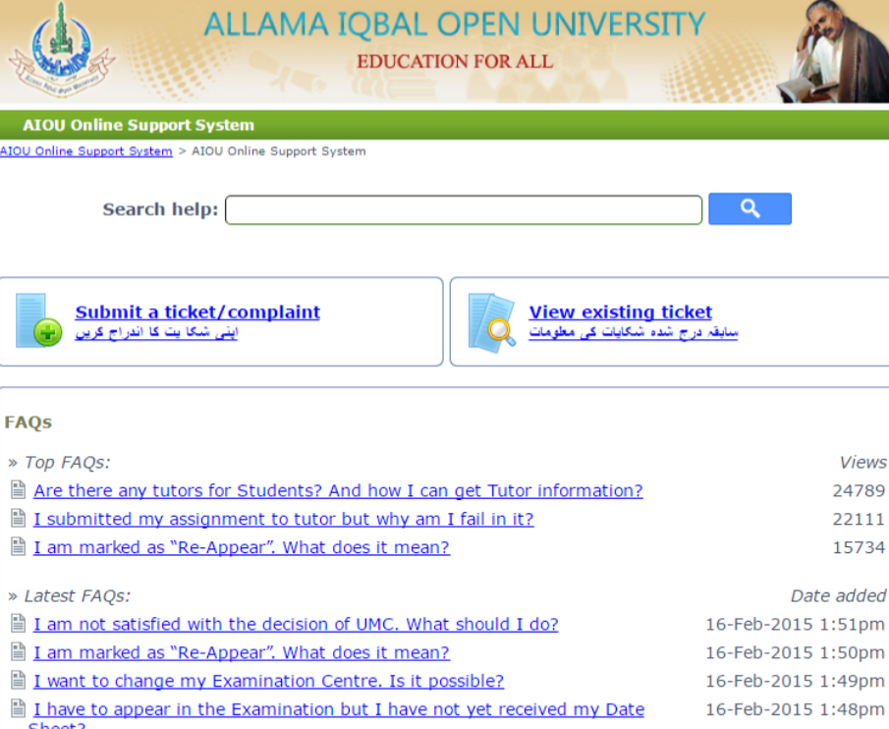
Figure 4. Interface of Online Student Support System

Automated Incident Reporting Management System Using Mobile Technology [50]
It is a two-level application that was created to serve the Butuan City Police Office (BCPO) in the Philippines to automate incident reporting and enhance the response time and veracity. It comprises the iPolice Information System (a web-based system designed to aid police staff) and the iPulis Mobile App (designed to assist citizens). The modules of paramount importance are user maintenance (profiling users, authenticating citizens, and scheduling police activities), incident reporting (recording reports with the help of mobile devices and GPS coordinates, time stamps, and ensuring its authenticity), and enterprise reporting (visualizing data using pie charts to provide summaries of incidents and interactive querying of historical data). It was built with Rapid Application Development (RAD) and Agile Prototyping, and includes Python (Flask) and Node.js, mobile through Cordova, MySQL database and cloud computing on Google App Store. The quality of the software in the system was tested under the standard of ISO/IEC 9126-1 where it scored highly on functionality, reliability, usability, efficiency, maintainability, and portability.

The safety incident reporting element of this system was incorporated into the proposed AMSIRS. This, in the proposed system, will be integrated with attendance track, and organization management to enable automatic alerts, data representation of incidence, and smooth communication between students, faculty and administration to respond swiftly to campus emergencies.
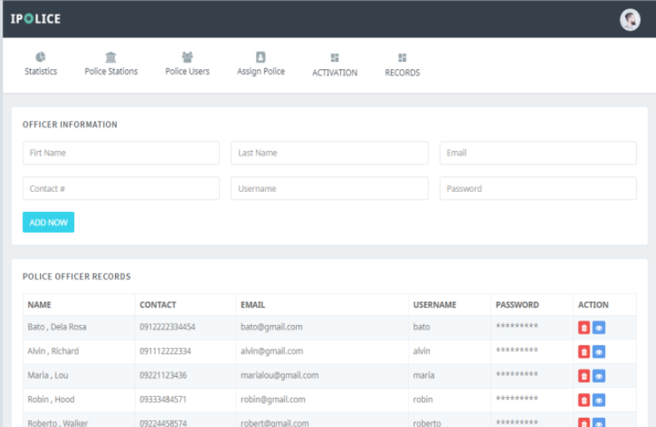
Figure 5. Interface of Automated Incident Reporting Management System

AttenFace: A Real Time Attendance System Using Face Recognition [51]
AttenFace system uses image processing and face recognition software to take class attendance automatically. Using cameras to scan and analyze faces, it prevents proxy attendance and cuts down time wasted on manual roll-calls. Digital storage of attendance data makes data retrieval and maintenance easy. Its advantage is in offering a contact-free, efficient solution that raises classroom productivity without sacrificing accuracy. The suggested research can embrace its utilisation of automated face recognition as a scalable and reliable option to conventional attendance practices.
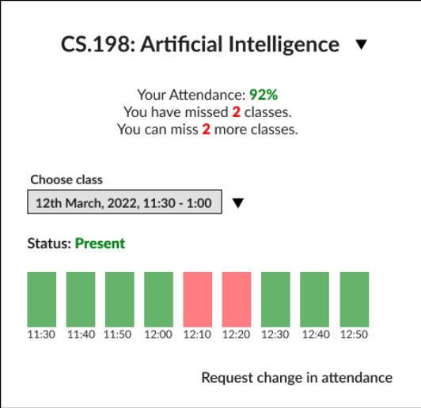
Figure 6. Interface of AttenFace for Students
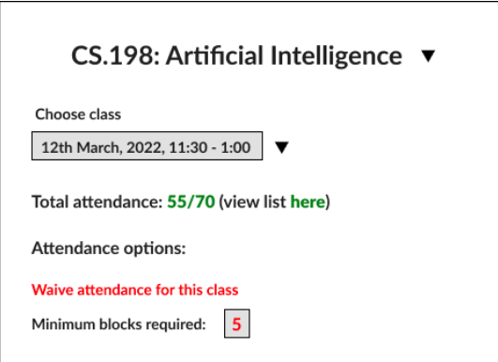
Figure 7. Interface of AttenFace for Faculty Members
Secure School: Enhancing Student Safety with Technology [52]
The Secure School system aims to increase the security and accountability of students using RFID and GPS-based tracking. The system ensures real-time monitoring of students' attendance and transport, providing parents and administrators with dashboards that reflect entry, exit, and travel records. The parents are alerted in real-time whenever students enter or exit school campuses, promoting transparency and security. The predictive analytics functionality also detects abnormal attendance patterns, making it a forward-looking feature for managing students. The real-time alert and GPS tracking integration in this software can motivate features for the suggested study to guarantee precision and security in tracking attendance.
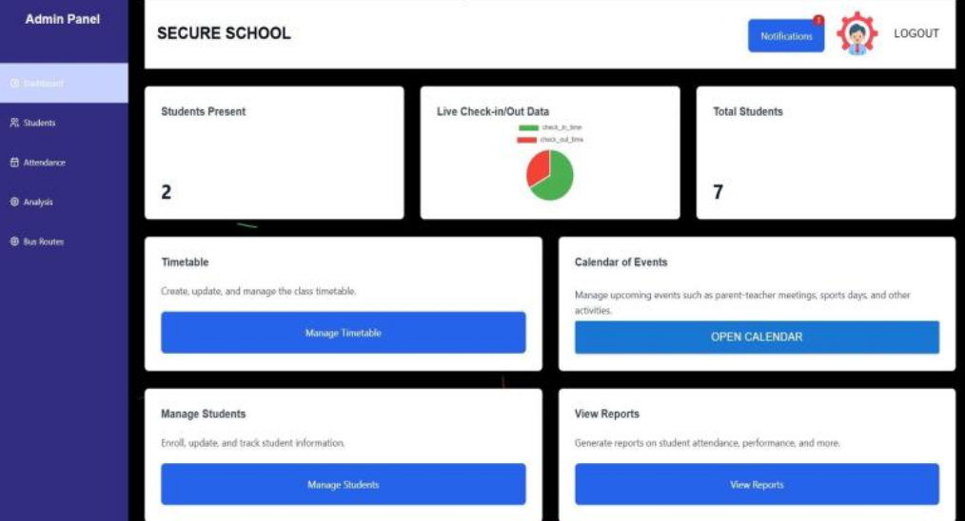
Figure 8. Interface of Secure School
Automated Attendance and Analytics System [53]
The Automated attendance and analytics system that is discussed in the paper is a web-based system that will automate the student attendance tracking system and also will offer real time data analytics to learning institutions. It will help to solve the issue of inefficiencies of manual roll calls by using face recognition and artificial intelligence to capture attendance and avoiding proxy entries. Relying on the backend frameworks such as Flask or Django and MySQL database, and the frontend ones such as React or Angular, the system is user-friendly and has a secure interface. It involves student registration modules, student marking attendance modules, which is a facial recognition module, and a centralized database to store the attendance records.
The proposed AMSIRS is an implementation of this system by borrowing the attendance and analytics functionalities that will be incorporated in the system, and adding the features of facial recognition-based biometric authentication, automated data capture, and visualization tools. All these features will serve to enhance precision, minimize human involvement, and assist data-driven decision-making on the campus grounds, and they will be supplemented by other modules, including safety incident reporting.
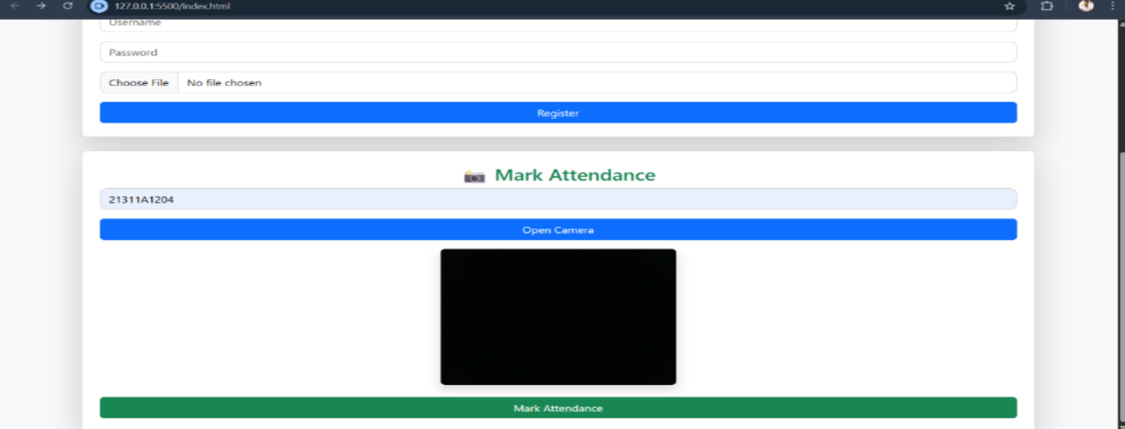
Figure 9. Interface of Automated Attendance and Analytics System
- Review Synthesis
Integrated campus systems to monitor attendance, safety incidents, and student support of institutions have become an important field in educational technology due to the necessity to increase efficiency, safety, and administrative control in academic institutions [23][25]. An overview of the analyzed literature and the associated systems shows that there are several important themes and results. To begin with, biometric technologies prevail in terms of attendance control, and research focuses on face recognition [19][37], fingerprint scanning [41], and RFID [31][39] to automate the processes and decrease the number of errors such as proxy attendance. As an example, deep learning-based systems like FaceNet over MobileNetV2 can reach an accuracy rate of 97–99% in real-time [42], whereas RFID-IoT systems emphasize the advantages of scalability, as well as accuracy of data in the educational context [31].
Second, safety incident reporting is centered around anonymous and mobile platforms, which allow related notification and data-driven reaction to threats such as violence or emergencies. Anonymous Reporting Systems (ARS) in schools have been reviewed as having potential to overcome the so-called code of silence among schoolchildren, but the use of such systems is still low unless used with adequate training. Third, the student support literature highlights web-based platforms that centralize student data and provide role-based dashboards, offering design insights applicable to the AMSIRS Student Support module. Fourth, IoT, AI, and data analytics could be integrated into a unified system, such as smart campuses, which in the case of the ERP frameworks of Philippine universities, places a primary focus on strong leadership and ICT preparedness to operate efficiently.
Fifth, data analytics and reporting can be classified as cross-cutting components [21][22], and predictive insights about risks can be made using big data intelligence [38], and stakeholder transparency can be provided with the aid of dashboards [53]. Sixth, issues are privacy concerns [37][41], particularly as biometrics processes sensitive data, and requirements of empirical validation by conducting large-scale testing as a measure of reliability in varying environments [33][34]. Seventh, the transformation of manual to automated approaches is observed in numerous studies, which minimizes the administrative load and enhances the access in real-time using cloud and mobile integration [32][34][47]. Eighth, ethical concerns, including data security and biasness in AI models, are under-investigated, and a balanced approach to the system design should be considered [38][41]. Ninth, future directions have a tendency to suggest multimodal biometrics, anti-spoofing, and cross-platform compatibility to improve the robustness [43][34]. Tenth, in general, the literature substantiates the viability of open-source tools to cost-effective implementations that would open the way to the customizable solutions in resource-constrained institutions [29][32].
These results are very pertinent to the proposed AMSIRS since they will offer a baseline of how to integrate the various technologies into a unified system that facilitates the running of the campus. The focus on biometric attendance directly translates to the novelty of the proposal of monitoring since the contactless verification can be done through face recognition or RFID to remove manual errors and proxy since it is an objective to monitor student attendance efficiently. The literature of safety reporting, like ARS and big data models, assists in improving incident reporting with the use of mobile applications, including GPS and multimedia, allowing anonymous reporting and real-time notifications to achieve a safe environment.
Web-based systems provide insights into the student support and thus provide blueprints of digitalization, which the proposed system can use through centrally managed dashboards and role-based access. The reviewed integrated frameworks, such as smart campuses and ERP, confirm the purpose of the proposal to achieve data interoperability and scalability, with the help of AI and databases, to bridge attendance, safety, and student support modules. The issues such as privacy and scalability mentioned in the reviews also indicate that the proposed system should be provided with effective security measures and empirical testing, which would guarantee compliance with ethics and flexibility.
The system can further improve on the current solutions by filling the gaps in the system, including limited empirical data and ethical lapses [38][36], providing predictive analytics concerning trends, including absenteeism or risk [47]. It is also applicable to practical applications, where the literature open-source tools will allow the minimization of costs of development [29], and the system will become accessible to educational institutions in the Philippines. Finally, these results support the idea of the proposal to develop a single digital environment that encourages transparency, efficiency, and proactive management. By working in collaboration with student support to collect and verify data, the system can draw on such insights to provide a customized and user-friendly solution that will address practical campus requirements.
To sum up, the literature and systems synthesis has shown that such aspects as biometrics and reporting applications are already well-researched, but actual integration is an untapped but potentially fruitful field [25], which justifies a comprehensive approach of the proposed system. This applicability can be seen in how the results cover some of the inefficiencies in the old campus operations, including time-consuming manual operations [29], data silos, which the integrated system is supposed to minimize the usage of, through centralized technology [23]. Using the recognized strengths as high precision in AI-based attendance [43] and real-time safety notifications [52], the proposal can balance weaknesses, such as scalability problems and privacy lapses, by implementing cloud architecture and governance capabilities [32][39].
The human-centered designs suggested in the literature are in agreement with the stakeholder involvement in the system, which makes its usability to students, staff, and administrators a guarantee [24][35]. The reviews may also be used to inspire future improvements, adding such features as environmental monitoring with the help of IoT sensors [40] or risk prediction with the help of machine learning [38], extending the area of the system. The lack of empirical information in the current literature demonstrates the significance of the suggested validation stage during which the cooperation with the student support will yield actual data to debug and optimize the platform [33]. This does not only help bridge theory with practice but also give back to the discipline by filling the gaps, including multi-institutional pilots. In general, the results confirm the relevance of the proposal in the era of digital transformation and place it in the position to enhance academic accountability and security. The system, through this integration, will have quantifiable effects, such as a decrease in the response time to incidents and increased student participation in student support. Lastly, basing the solution proposed on these reviews will place it in a position to innovate the campus management that can maintain a smooth and data-driven educational environment.

Chapter 3
METHODOLOGY

Software Methodology
The study adopts the V-Model (Verification and Validation Model). The reason this methodology has been chosen is that it offers a very disciplined, symmetric approach to software engineering, with each phase of development directly matched with a testing phase on the right side of the "V" approach. This guarantees that the critical demands of the system, which are biometric accuracy, data privacy, and automated intervention logic, are checked and proven at each level of the system architecture.
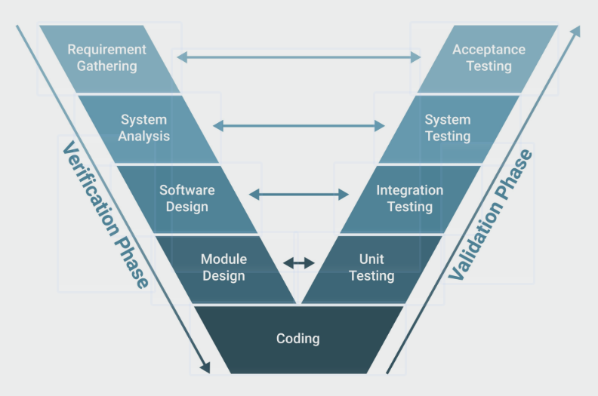
Figure 10. V-Model (Verification and Validation Model) Visualization

The phases of the V-Model (Verification and Validation Model) used in this study are as follows:

3.1.1 Requirement Analysis and Acceptance Test.
The Requirement Analysis phase involves carefully documenting the functional and non-functional requirements of Cavite National High School. This involves setting environmental parameters for the Face Recognition module (such as lighting conditions and student throughput at the gates) and establishing workflow guidelines in the event of a safety incident. Simultaneously, the researchers develop the Acceptance Testing Plan, which stipulates the exact criteria of success the system must meet to be accepted by the school administration, including achieving a minimum acceptable score on the System Usability Scale (SUS).

3.1.2 System Testing and System Architecture.
During the System Architecture phase, the researchers develop the high-level technical architecture, defining how the decentralized, client-side biometric engine (face-api.js) will securely transmit real-time mathematical descriptors to the centralized Supabase PostgreSQL cloud database. This phase determines how AMSIRS integrates its various modules by examining how the attendance, incident, and student support features interact through Next.js Server Actions. The respective System Testing Plan is drawn up to test the end-to-end integrated workflow—for example, ensuring that a "Time-in" log from the entry gate instantly synchronizes with the student's profile for administrative review without data latency.

3.1.3 Unit Testing and Module Design.
The module design stage concerns the low-level logic and internal mechanisms of specific components. This encompasses the implementation of the algorithms for extracting facial features locally in the browser, as well as programming the Role-Based Access Control (RBAC) middleware routing required to protect guidance counselor dashboards. In line with this, the Unit Testing Plan establishes the determined technical measures of success, such as the False Acceptance Rate (FAR) and the False Rejection Rate (FRR) of the face recognition module, ensuring that each block of code operates accurately in isolation before being combined.

3.1.4 Coding (Implementation)
At the bottom of the "V," the researchers implement the system's actual functionality utilizing a modern, scalable technology stack: Next.js, TypeScript, React, Supabase, and Tailwind CSS. The structural design specifications from earlier phases are converted into functional, type-safe source code. The access monitoring, incident logging, and student support modules are developed as separate, reusable React components to achieve strict modularity and long-term maintainability.

3.1.5 Verification & Validation (The Upward Path)
Upon completion of the coding phase, the system transitions to the right side of the "V," executing the specific test plans formulated during the preceding design and analysis phases. This ensures that every technical requirement is not only built but also rigorously verified for accuracy and performance.

Unit Testing: Conducted to evaluate the smallest components of the system in isolation. This includes testing individual UI components in React and the backend database querying logic in Supabase. The focus is on verifying algorithmic accuracy—specifically measuring the False Acceptance Rate (FAR) and False Rejection Rate (FRR) using local image arrays—and ensuring that strict data validation schemas (e.g., preventing empty incident reports) are enforced at the code level.

Integration and End-to-End (E2E) Testing: Following the verification of individual modules, the researchers perform comprehensive integration testing using Microsoft Playwright. This phase validates the synchronization between the web-based camera portals and the Supabase cloud database, ensuring real-time biometric log transmission without data corruption. The researchers executed a massive E2E testing suite consisting of 13 isolated specification files encompassing 169 distinct automated test cases. This suite rigorously verified the Role-Based Access Control boundaries, the AES-256 encryption process for secure forms, and the automated "Proactive Alert" logic that triggers notifications for the Student Support module. The testing suite achieved a 100% pass rate, empirically proving the system's technical reliability.

Validation & Acceptance Testing: The final stage of the methodology involves a formal pilot test with 30 respondents (Students, Faculty, and Security Personnel). During this phase, the system is evaluated in a real-world campus environment to ensure it meets the institutional requirements and research goals outlined in Chapter 1. The researchers use the System Usability Scale (SUS) to collect quantitative data on user satisfaction, ease of use, and overall system effectiveness, confirming that the integrated platform successfully addresses the school's administrative needs.

Research Methodology
3.2.1 Research Design
This study employs a descriptive quantitative research design aligned with the central research question, which seeks to determine how operational domains such as campus access monitoring, safety incident reporting, and student support services can be integrated into a unified AMSIRS to enable real-time data interoperability and proactive student intervention.

The descriptive approach ensures that user experiences and system interactions are captured under natural academic conditions. It does not manipulate variables but instead observes how users interact with the developed system in real-life scenarios. This design is highly effective for understanding the practical usability of software systems within educational institutions, where functionality, accessibility, and efficiency are key to adoption. Through this framework, the study provides quantifiable insights into how the system addresses administrative inefficiencies and supports institutional digital transformation.

3.2.2 Research Locale
The research will be conducted at Cavite National High School - Senior High School in Cavite City. The institution is an ideal environment for this study because its academic, student support, and safety processes align directly with the system’s three core modules. Conducting the usability evaluation within this specific academic setting ensures that the system is tested by individuals who actively engage in attendance, reporting, and student activity management daily. Official permission to conduct the study and pilot the system within their operational environment has been secured from the school administration.

By implementing the study at Cavite National High School, the researchers can assess how well the AMSIRS platform performs under realistic conditions where digital efficiency is essential. The chosen locale strengthens the external validity of the results, ensuring that the findings are practical, highly relevant, and applicable to real-world institutional operations.

3.2.3 Research Respondents
A total of 30 respondents will participate in this study, composed of 10 faculty members, 15 students, and 5 campus security personnel. These groups were purposely selected because they represent the primary end-users of the system and can provide diverse, role-specific feedback across its core functions. Faculty members and Discipline Coordinators oversee the student support systems, security staff monitor safety incidents and campus access, and students interact directly with the attendance scanners and portals. Their feedback will evaluate the system’s usability and functionality from multiple critical perspectives. By prioritizing participants directly involved in these workflows, the study guarantees that authentic user experiences and challenges are accurately reflected in the data.

3.2.4 Research Instrument
The study will utilize a combination of user-based and system-generated instruments to comprehensively evaluate the system.

For usability assessment, the System Usability Scale (SUS) will serve as the primary research instrument. The SUS is a widely recognized 10-item questionnaire that uses a 5-point Likert scale to measure users’ perceptions of ease of use, consistency, and overall satisfaction. It has been proven statistically reliable even in small-sample studies and provides a single usability score out of 100. After interacting with the system, respondents will complete the SUS questionnaire to identify the platform's usability strengths and weaknesses[54].

In addition to the SUS, the study will incorporate system-generated data logs as a secondary instrument to evaluate the performance of the face recognition feature. The system will automatically record data such as successful identifications, failed attempts, false positives, and false negatives during user interaction. These logs will be exported to compute performance metrics including accuracy, precision, recall, and F1-score. This combined approach ensures a standardized, data-driven evaluation process, allowing the researchers to objectively assess both human usability and technical reliability.

3.2.5 Data Gathering Procedure
The data gathering procedure is divided into two primary phases: securing ethical compliance and conducting the system evaluation through operational testing.
Prior to any data collection, formal authorization will be secured from the administration of Cavite National High School. Because this study involves the collection of biometric data (facial features) and behavioral records of minors, strict adherence to the Data Privacy Act of 2012 (Republic Act No. 10173) is enforced. Informed parental consent and explicit assent from the participating students will be obtained using physical consent forms. The forms will clearly detail that facial data will be stored temporarily as encrypted mathematical hashes rather than raw images, and that all records will be permanently purged following the conclusion of the system testing phase.
Once ethical clearances are secured, the operational testing will commence. Participants will be guided through a series of structured tasks designed to test the complete lifecycle of the system's integrated modules. The workflow will specifically test the automated data hand-off: the system retrieves records from recent safety incidents, the guidance office seamlessly accesses these flagged records, a counseling session is documented, and the final resolution is securely recorded back into the centralized database.

3.2.6 Samples and Sampling Techniques
The study applies a targeted, purposive participant selection method to ensure that only individuals directly involved with system-related processes are included. This focused approach allows researchers to collect meaningful feedback from respondents who have real-world experience with the system’s intended administrative functions. By doing so, the data obtained reflects authentic user experiences rather than general outsider opinions, providing highly accurate insights for usability improvement. This method enhances efficiency in data collection, as the chosen participants can effectively compare the AMSIRS platform's practical benefits against their traditional, manual administrative methods.

3.2.7 Statistical Treatment
The data collected in this study will be analyzed using a combination of descriptive statistics and performance evaluation metrics to provide a comprehensive assessment of the system.
For user evaluation, the results from the System Usability Scale (SUS) questionnaires will be analyzed using descriptive statistics, including the mean and standard deviation. The SUS score for each respondent will be calculated using the formula:

SUS Score = (Sum of adjusted item scores × 2.5)

This formula yields a usability score ranging from 0 to 100, where higher values indicate greater user satisfaction. The computed SUS scores will be summarized to determine the overall usability level of the system based on established industry benchmarks. [55]
In addition to usability, the performance of the face recognition component will be evaluated using accuracy metrics, including accuracy rate, precision, recall, and F1-score. These metrics will be derived from system-generated data to measure how effectively the system recognizes individuals entering and exiting the campus. By integrating both descriptive and performance-based statistical methods, the study ensures that findings are presented clearly, quantitatively, and objectively.

3.2.8 Technology Stack
The development of AMSIRS requires a combination of modern programming languages, frameworks, and development tools to ensure that the system operates efficiently, securely, and reliably. The selected technology stack enables the seamless integration of face recognition attendance monitoring, encrypted incident reporting, and student support services into a unified digital ecosystem.
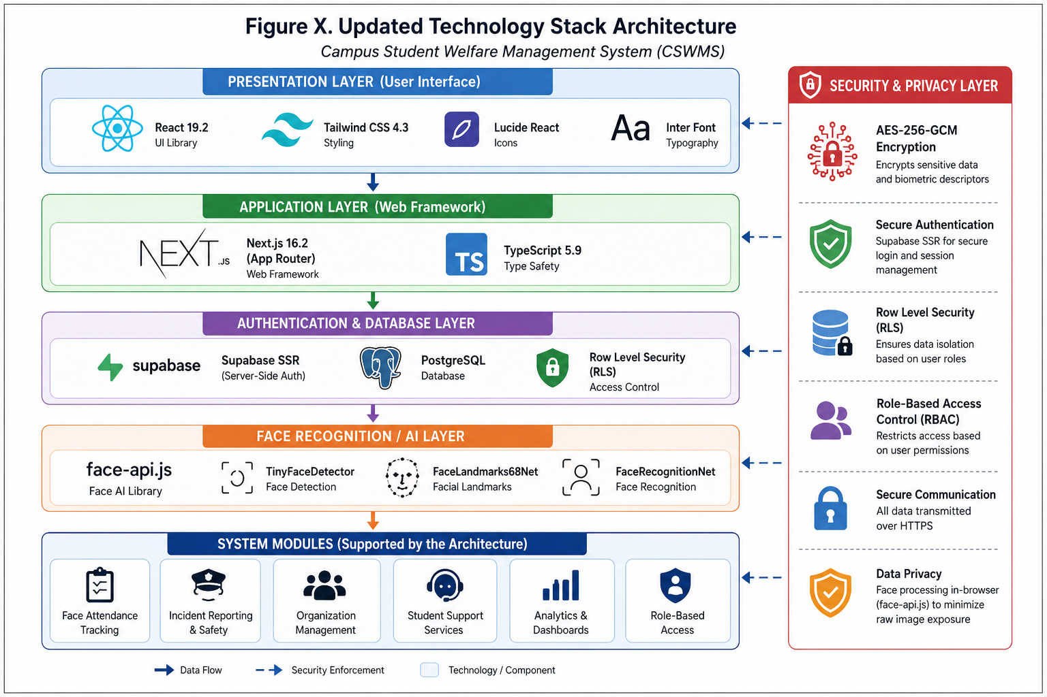
Figure 11. Technology Stack Visualization
For the core application framework, the researchers utilized Next.js, a powerful React-based framework powered by Node.js. TypeScript serves as the primary programming language, bringing strict type-safety to JavaScript. This architecture handles the system’s core logic, including server-side rendering, API routing, and secure communication between the frontend interface and the database. Utilizing Next.js Server Actions allows the system to manage complex data mutations and real-time operations efficiently without exposing backend logic to the client.

For database management and backend services, the system employs Supabase, an open-source Firebase alternative built on a PostgreSQL relational database. Supabase provides real-time database subscriptions, robust cloud storage, and secure server-side authentication. The use of a relational PostgreSQL database ensures strong data integrity for critical system records such as student profiles, attendance logs, incident reports, and counseling interventions. Its real-time synchronization capabilities allow administrators and authorized personnel to access updated information instantly, improving the system’s responsiveness.

Contrary to traditional backend-heavy biometric systems, the face recognition component of the attendance monitoring module is developed using face-api.js, a JavaScript API built on top of TensorFlow.js core. This decentralized module processes captured video streams from cameras at the campus entry and exit points entirely in real-time within the browser, verifying student identities and automatically logging attendance directly from the gate terminals.

For frontend development and user interface design, the system utilizes React components styled with Tailwind CSS. Tailwind provides a utility-first CSS framework that ensures the web portal remains highly accessible, responsive, and compatible across varying devices and screen sizes. Additionally, Framer Motion is integrated to provide fluid micro-animations, enhancing the overall user experience and interface intuitiveness. By integrating these technologies, the proposed system achieves a modular, scalable, and highly secure architecture.

3.2.9 Security & Privacy Measures
The proposed system implements multiple security and privacy mechanisms to ensure the protection of sensitive student information, biometric data, attendance records, and organizational intelligence. Since the system processes facial recognition descriptors and highly confidential institutional records, maintaining confidentiality, integrity, and secure access control is paramount.
The system uses Supabase Server-Side Rendering (SSR) Authentication for secure session management and controlled access to system resources. Authentication is handled exclusively on the server side via encrypted HTTP-only cookies to eliminate the exposure of sensitive session tokens on the client side. In addition, Row-Level Security (RLS) policies are strictly implemented within the PostgreSQL database. These policies act as a gatekeeper, restricting unauthorized access to rows of data based on the authenticated user's specific role.
To secure highly sensitive information, such as incident reports and disciplinary logs, the system utilizes the Node.js Crypto module to implement AES-256-GCM encryption. This military-grade encryption standard provides authenticated encryption, ensuring that confidential data remains completely unreadable during storage. Even if the database is compromised, the encrypted reports cannot be deciphered without the heavily guarded environment decryption keys.
Furthermore, the facial recognition module significantly enhances data privacy by processing facial detection and generating 128-dimensional biometric descriptors locally within the browser using face-api.js. This architectural decision means that raw biometric image data (video feeds or photos) is never transmitted to or stored on external servers. Only the mathematical descriptors are securely transmitted, vastly reducing the risk of identity theft or privacy breaches. Finally, the entire codebase is written in TypeScript 5, which enhances application reliability and minimizes runtime vulnerabilities through strict type validation.

3.2.10 Ethical Considerations
The development and implementation of the AMSIRS (A Web-Based Integrated Institutional System for Access Monitoring, Safety Incident Reporting, and Student Support) involve the processing of sensitive personal information, including student profiles, attendance records, safety incident reports, counseling-related information, and biometric facial data used for access monitoring. Therefore, ethical principles concerning privacy, confidentiality, transparency, and responsible data handling were incorporated throughout the study and system development process.
To protect the rights and welfare of students and other stakeholders, the system adheres to the principles established under the Data Privacy Act of 2012 (Republic Act No. 10173). Personal and biometric data collected by the system are limited only to information necessary for attendance monitoring, incident documentation, and student support services. Data collection follows the principle of data minimization to reduce unnecessary exposure of sensitive information.
Prior to enrollment in the face recognition module, students and their parents or guardians, where applicable, shall be informed of the purpose of biometric data collection, how the data will be stored, and the intended use of the information. Appropriate consent procedures shall be observed in accordance with institutional policies and applicable regulations.
AMSIRS implements role-based access control to ensure that only authorized personnel can access specific categories of information. Security personnel are granted access only to functions related to access monitoring and incident documentation, while guidance counselors may access records necessary for student intervention and support. Administrative access is restricted according to assigned responsibilities to prevent unauthorized disclosure of confidential information.
Facial images and biometric templates are stored securely and are utilized exclusively for identity verification and attendance logging purposes. The system does not perform facial surveillance, behavioral prediction, emotion detection, or any form of automated profiling beyond attendance verification. Likewise, incident reports and student support records are treated as confidential and may only be accessed by authorized personnel with legitimate institutional responsibilities.
To promote fairness and accountability, the face recognition module is evaluated under different operational conditions to assess accuracy and minimize recognition errors. Alternative verification procedures are provided whenever technical limitations prevent successful facial recognition, ensuring that students are not unfairly affected by system-related inaccuracies.
Finally, all collected information shall be retained only for the period necessary to fulfill institutional requirements and shall be securely disposed of in accordance with established data retention and privacy policies. Through these ethical safeguards, AMSIRS seeks to enhance campus safety, administrative efficiency, and student welfare while upholding the privacy, dignity, and rights of all individuals whose information is processed by the system.

3.2.11 Face Recognition Module Testing and Evaluation
To ensure the accuracy and reliability of the Face Recognition module, a technical testing phase will be conducted alongside the usability study. The system’s performance will be evaluated using the False Acceptance Rate (FAR), which measures the likelihood of unauthorized access, and the False Rejection Rate (FRR), which measures the failure to recognize authorized students. Tests will compare automated biometric attendance logs against manually verified ground-truth records to calculate these metrics.
Environmental stress testing will also be performed to assess the system's robustness under varying real-world conditions. This includes evaluating performance across different lighting scenarios (e.g., morning glare, low-light afternoon shadows) and high student throughput at entry points during peak hours. These tests will provide quantitative, empirical evidence of the module’s effectiveness and operational reliability.
3.2.12 Functional Requirements
Functional requirements define the specific services and functionalities that a software system must provide to satisfy user needs and organizational objectives [56]. These requirements were identified through the requirements gathering process, review of related literature, and consultations with stakeholders, including school administrators, guidance personnel, and security officers.
Requirement ID | Description
FR-01 | The system shall authenticate users through secure login credentials.
FR-02 | The system shall register and manage student records.
FR-03 | The system shall capture attendance using facial recognition technology.
FR-04 | The system shall generate attendance logs automatically.
FR-05 | The system shall allow authorized users to create and manage incident reports.
FR-06 | The system shall maintain student support and intervention records.
FR-07 | The system shall notify relevant personnel regarding flagged incidents and student concerns.
FR-08 | The system shall generate reports and analytics for attendance, incidents, and interventions.
FR-09 | The system shall enforce role-based access control for administrators, guidance personnel, security officers, and students.
FR-10 | The system shall provide dashboard visualizations for monitoring institutional activities.
Table 1. Functional Requirements of AMSIRS
The identified functional requirements support the integration of attendance monitoring, incident reporting, and student support services within a centralized platform. Integrated educational information systems improve administrative efficiency, reduce data redundancy, and facilitate timely decision-making through centralized access to institutional information [57], [58].

3.2.13 Non-Functional Requirements
Non-functional requirements specify the quality attributes and operational constraints that determine how a system performs its intended functions. These requirements ensure that the system remains secure, reliable, efficient, and usable under various operating conditions [59].
Requirement ID | Description
NFR-01 | The system shall maintain an average response time of less than three seconds during normal operation.
NFR-02 | The system shall provide secure authentication and authorization mechanisms.
NFR-03 | The system shall protect sensitive student information through encryption and secure transmission protocols.
NFR-04 | The system shall support cross-browser compatibility across modern web browsers.
NFR-05 | The system shall be responsive and accessible on desktop, tablet, and mobile devices.
NFR-06 | The system shall maintain data integrity and prevent unauthorized modifications.
NFR-07 | The system shall achieve high system availability during institutional operating hours.
NFR-08 | The facial recognition module shall provide reliable identification performance under normal environmental conditions.
NFR-09 | The system shall comply with the provisions of the Philippine Data Privacy Act of 2012 regarding personal information processing.
NFR-10 | The system shall support scalability for increasing numbers of users and records.

Table 2. Non-Functional Requirements of AMSIRS

3.2.14 Cross-Browser Compatibility Testing
Cross-browser compatibility testing was conducted to verify that AMSIRS functions consistently across different web browsers. The objective of this testing was to ensure that system features, user interfaces, and functionalities behave as intended regardless of the browser platform used by end users.
Compatibility testing is essential for web-based applications because browser rendering engines may interpret web technologies differently, potentially affecting system functionality and user experience. Through cross-browser testing, interface inconsistencies, display errors, and functionality issues can be identified and corrected before deployment [61].
The system was evaluated using Google Chrome, Microsoft Edge, Mozilla Firefox, Opera and Safari through BrowserStack. Testing was performed to verify the compatibility of the login functionality, dashboard display, attendance monitoring module, incident reporting module, student support module, report generation features, navigation components, and responsive layouts across different browser environments.

Browser | Browser Version | Operating System
Google Chrome | Latest Stable Version | Windows 11
Microsoft Edge | Latest Stable Version | Windows 11
Opera | Latest Stable Version | Windows 11
Mozilla Firefox | Latest Stable Version | Windows 11
Safari | Latest Stable Version | macOS / iOS

Table 3. Browsers Used for Cross-Browser Compatibility Testing
3.2.15 Device Compatibility Testing
Device compatibility testing was performed to determine whether AMSIRS can operate effectively across various device types and operating systems. This testing evaluated system responsiveness, functionality, and accessibility on devices commonly used by administrators, security personnel, guidance personnel, and students.
Educational information systems should maintain usability and accessibility across multiple devices to accommodate diverse user preferences and technological environments [62]. Device compatibility testing helps ensure consistent user experience regardless of screen size or operating system.
Device compatibility testing was performed using BrowserStack to evaluate the responsiveness, accessibility, and functionality of AMSIRS across multiple device categories. The testing focused on verifying proper interface rendering, navigation behavior, attendance monitoring functions, incident reporting features, and dashboard accessibility across desktop, laptop, smartphone, and tablet environments. This ensured that the system maintained consistent performance and usability regardless of device type or operating system.

Device Type | Evaluation Criteria
Desktop Computer | Full functionality and interface rendering
Laptop Computer | Full functionality and responsiveness
Android Smartphone | Mobile responsiveness and feature accessibility
iPhone (iOS) | Mobile responsiveness and feature accessibility
Tablet Device | Layout adaptation and usability

Table 4. Device Compatibility Testing Criteria

3.2.16 Performance Testing
Performance testing was conducted to evaluate the responsiveness, stability, and efficiency of AMSIRS under varying workload conditions. The purpose of this testing was to determine whether the system could maintain acceptable performance levels when accessed simultaneously by multiple users.
Performance testing is necessary for identifying system bottlenecks, measuring response times, and assessing system scalability under increasing workloads [63]. For educational information systems, performance testing is particularly important because multiple stakeholders may access the system concurrently during peak operational periods.
The testing involved simulating different user loads to evaluate system behavior under low, medium, high, and peak usage conditions.
Scenario | Concurrent Users
Low Load | 10 Users
Medium Load | 25 Users
High Load | 50 Users

Table 5. Performance Testing Scenarios

3.2.17 Use Case Diagram
The use case diagram illustrates the interactions between the different users and the AMSIRS platform. It provides a visual representation of how each actor interacts with the system to perform specific functions related to attendance monitoring, incident reporting, and student support services.
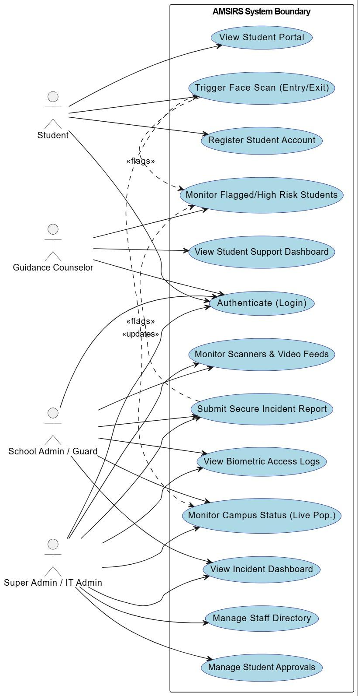
Figure 12. Use Case Diagram Visualization

The primary actors in the system include students, security guards, administrators, and guidance counselors, each with specific roles and permissions. Students can log attendance through the face recognition system and submit incident reports. Security guards review incident reports and monitor attendance records at campus entry points, while administrators manage user accounts and overall system configuration. Guidance counselors handle student support services and counseling records.

The database architecture underpinning these use cases is built upon five primary entities: Student, Staff, Attendance_Log, Incident_Report, and Support_Intervention.

The Student entity functions as the central node of the system, utilizing a unique StudentID as its primary key and containing the encrypted mathematical hash of the student's facial data for biometric verification. This central profile is linked via one-to-many relationships to both the Attendance_Log and the Incident_Report entities, allowing the system to maintain a comprehensive historical record of a student's physical presence and behavioral infractions. The Staff entity utilizes role-based attributes to define system access and is linked to the incident and intervention modules based on user authorization.

Crucially, the Entity-Relationship logic defines a direct linkage between the Incident_Report, Attendance_Log, and Support_Intervention entities. This specific data structure serves as the foundational architecture for the system's automated intervention logic. When a severe safety incident or multiple absences are recorded, the database structure allows the Student Support module to seamlessly retrieve the flagged records using Foreign Keys, enabling guidance counselors to initiate interventions without relying on delayed, manual data hand-offs. Together, these defined relationships ensure real-time data synchronization and proactive monitoring across all operational domains.

3.2.18 Entity Relationship Diagram
To support the complex, real-time interactions outlined in the Use Case Diagram, the database architecture was rigorously designed using a relational PostgreSQL schema hosted on Supabase. The ERD maps the strict relationships and Foreign Key constraints that ensure data integrity and prevent orphaned records. The core identity architecture revolves around the Supabase auth.users table. This central authentication table extends out to three distinct profile tables: students, user_profiles (for guards and counselors), and system_admins.
The students entity functions as the central operational node of the database. It is linked via one-to-many relationships to the system's three functional domains:
Access Monitoring: The students table is strictly linked to the face_embeddings table (which securely stores the mathematical JSONB descriptors required for biometric matching) and the access_logs table (which records the timestamp, action, and snapshot of every gate scan).
Incident Reporting: Rather than a direct link, the database utilizes a bridging table called incident_involvements. This structure allows a single incident_reports record (created by an authorized staff member) to be linked to multiple students simultaneously, accurately categorizing each student's role as an Offender, Victim, or Witness.
Student Support: The database schema inherently models the system's proactive intervention logic through the student_flags and support_interventions entities. The student_flags table maintains a one-to-one relationship with the student, automatically aggregating their incident severity counts. When a threshold is met, the system flags the student, allowing the Guidance Counselor to create a record in the support_interventions table, which securely links the counselor's ID to the student's ID alongside encrypted session notes..
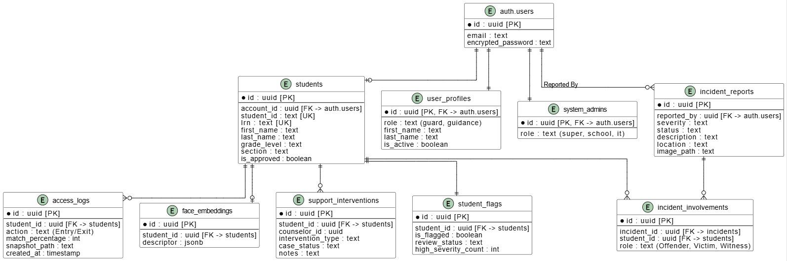
Figure 13. Entity Relationship Diagram (ERD) of AMSIRS
This highly normalized relational architecture ensures that the disparate domains of attendance tracking, safety reporting, and behavioral counseling are intrinsically unified at the database level, enabling the seamless real-time data synchronization required by the AMSIRS platform.

Chapter 4
RESULTS AND DISCUSSION
4.1 System Evaluation and Automated Testing
To empirically validate the functional reliability, security boundaries, and user interface responsiveness of the AMSIRS platform, an exhaustive End-to-End (E2E) automated testing phase was executed. The testing was conducted utilizing Microsoft Playwright, a modern testing framework capable of simulating real-world user interactions within a headless Chromium browser environment. The primary objective of this testing phase was to ensure that the core operational requirements — specifically Role-Based Access Control (RBAC), biometric gate UI rendering, encrypted data submission, and automated student support flagging — functioned flawlessly prior to physical deployment.

4.1.1 Testing Scope and Objectives
The system was partitioned into 13 distinct testing suites, each targeting a specific operational module of the AMSIRS platform. To optimize testing speed and avoid redundant login operations, a programmatic global-setup.ts file was implemented to pre-authenticate the five primary user roles (Super Admin, IT Admin, School Admin, Student, and Guidance Counselor) simultaneously. Table 6 outlines the specific focus and testing objectives for each of the 13 core modules evaluated during this phase.

Test Suite File | Module Focus | Primary Testing Objective
01-login | Authentication | Validate the rendering of login components, verify error handling for invalid credentials, and ensure the system correctly redirects authenticated users to their role-specific dashboards.
02-register | Student Registration | Ensure all required demographic fields render correctly, validate the presence of the Data Privacy Act (DPA) consent checkbox, and verify the biometric ID photo capture guidelines.
03-sidebar | Role-Based UI | Confirm that the navigation sidebar dynamically renders links based on the authenticated user's clearance level and properly visually highlights active routes.
04-admin-dashboard | Staff Management | Validate the display of the staff directory, role filter dropdowns, functioning search bars, and the rendering of "Active/Suspended" status badges.
05-admin-dashboard | Student Management | Verify the rendering of the student body directory, grade filters, pagination controls, and the visibility of the "Bulk Approve" action triggers.
06-incident-reporting | Secure Forms | Test the dynamic generation of the incident report form, including dynamic multi-student tagging, severity dropdowns, and the presence of the AES-256 encryption security badge.
07-incident-dashboard | Incident Logs | Validate the real-time aggregation of statistical cards (Total Reports, High Severity) and ensure the dynamic table correctly filters incidents by location.
08-student-portal | Student Interface | Ensure the authenticated student's unique UUID, demographics, and encrypted "Involvement Logs" render accurately within their restricted identity matrix.
09-student-support | Counselor View | Validate the "Flagged Students" algorithmic rendering, ensuring high-risk students trigger visibility on the dashboard, and test the initial data-fetching loading states.
10-access-logs | Biometric Trails | Verify the rendering of historical gate scans, including match percentage UI, and test the functionality of date and action (Entry/Exit) filtering mechanisms.
11-campus-status | Live Population | Confirm the real-time rendering of the "Current Population" statistical integer and the presence of the active network status indicators.
12-gate-pages | Access Scanners | Validate the WebRTC video element mounting, "Awaiting Scan" algorithm states, and the visibility of continuous Data Privacy compliance notices at the Entry and Exit gates.
13-authorization | Security Boundaries | Rigorously test URL manipulation to ensure unauthenticated users are blocked, and students cannot bypass middleware routing to access administrative or security dashboards.
Table 6. End-to-End Test Suite Objectives

4.1.2 Comprehensive Execution Results
The complete testing suite consisted of 169 distinct automated test cases. The Playwright execution engine simulated thousands of rapid DOM (Document Object Model) interactions, verifying element visibility, text matches, and URL routing logic across all user roles. The entire suite executed in approximately 1.3 minutes, highlighting the efficiency of the Next.js server-side rendering architecture and the global-setup authentication strategy. Table 7 provides the exhaustive execution results for every individual test case conducted against the AMSIRS platform.

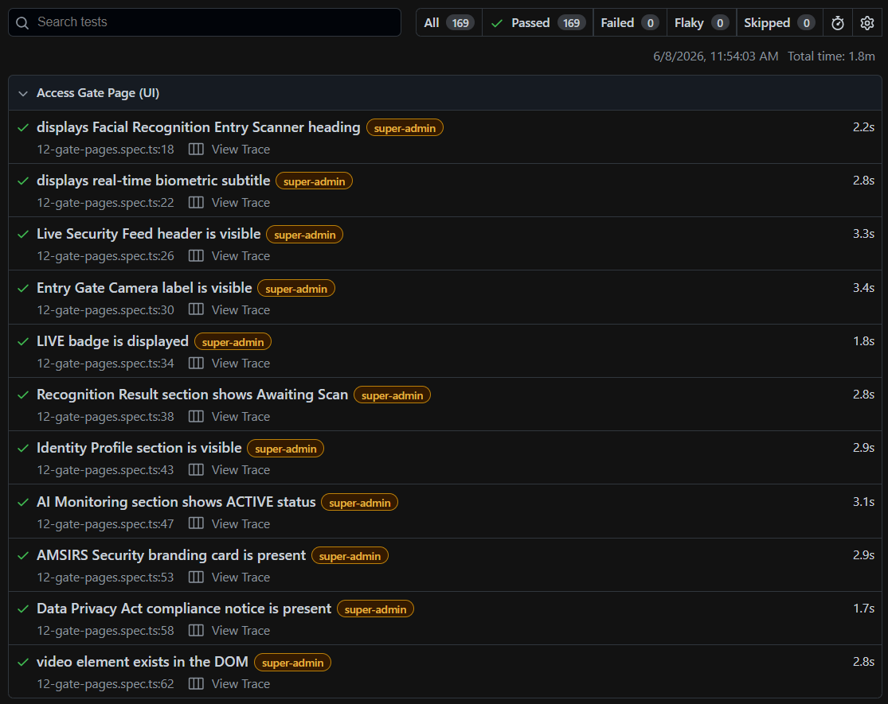
Figure 14. End-to-End Test Results of the Access Gate Page
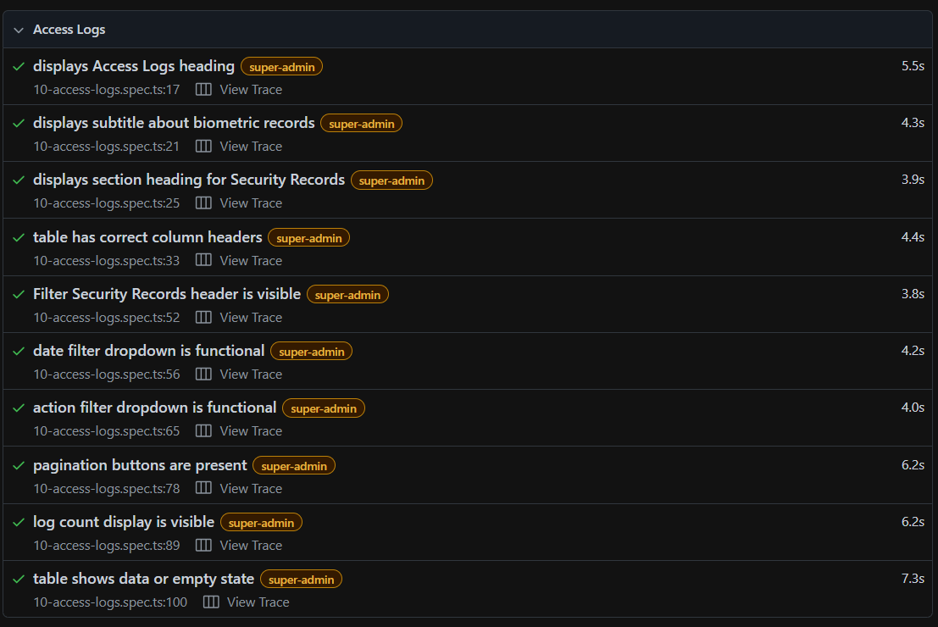
Figure 15. End-to-End Test Results of the Access Logs Page
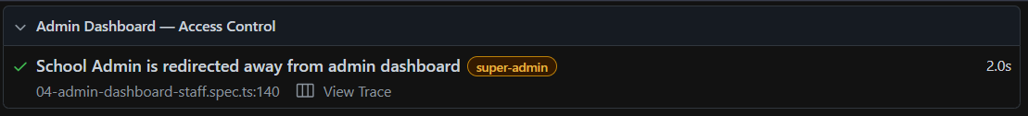
Figure 16. End-to-End Test Results of the Admin Dashboard - Access Control
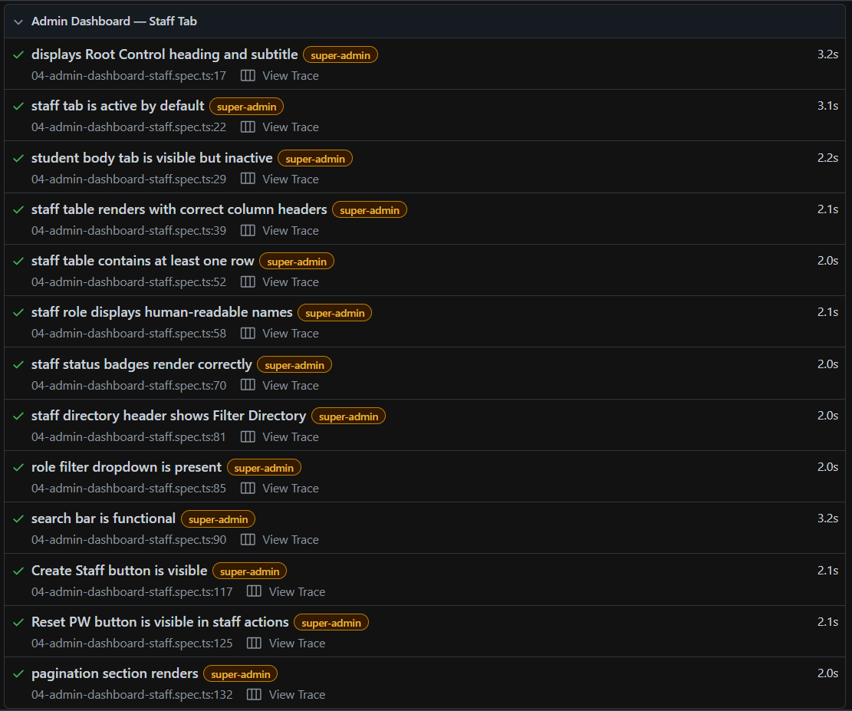
Figure 17. End-to-End Test Results of the Admin Dashboard - Staff Tab
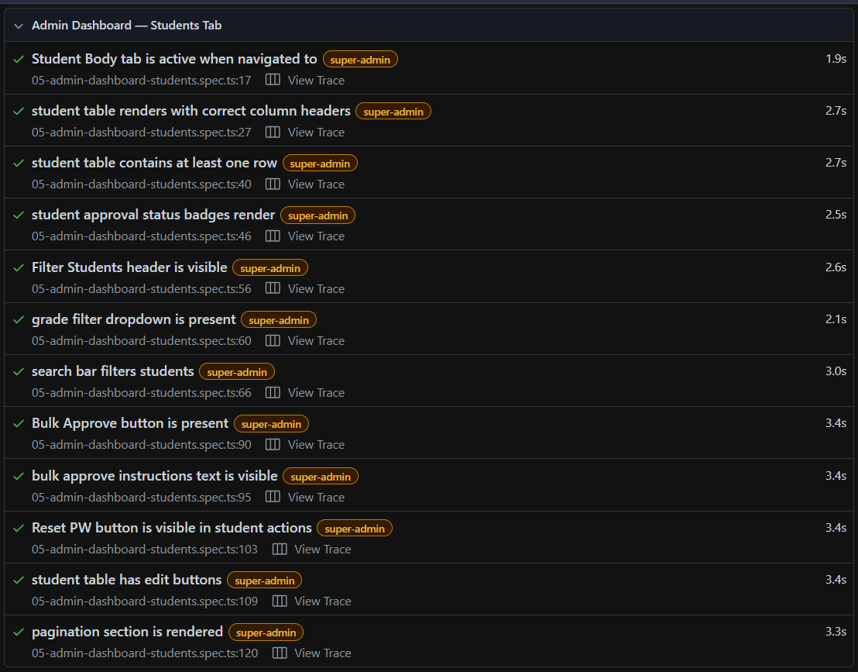
Figure 18. End-to-End Test Results of the Admin Dashboard - Students Tab
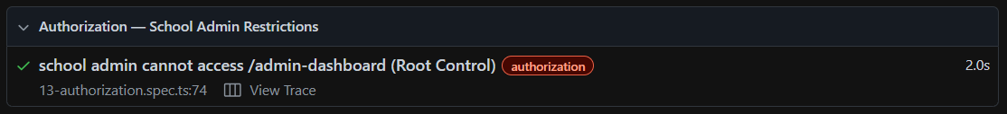
Figure 19. End-to-End Test Results of the Authorization - School Admin Restrictions
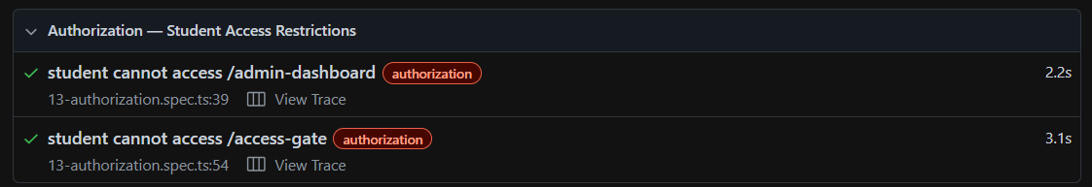
Figure 20. End-to-End Test Results of the Authorization - Student Access Restrictions
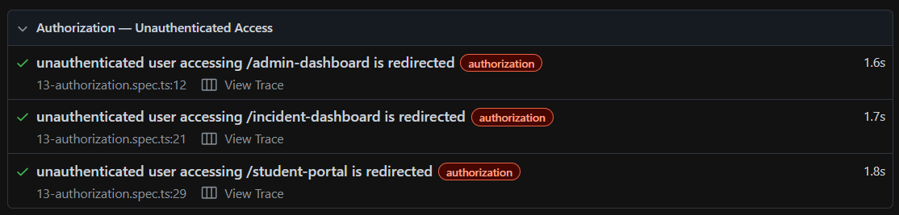
Figure 21. End-to-End Test Results of the Authorization - Unauthenticated Access
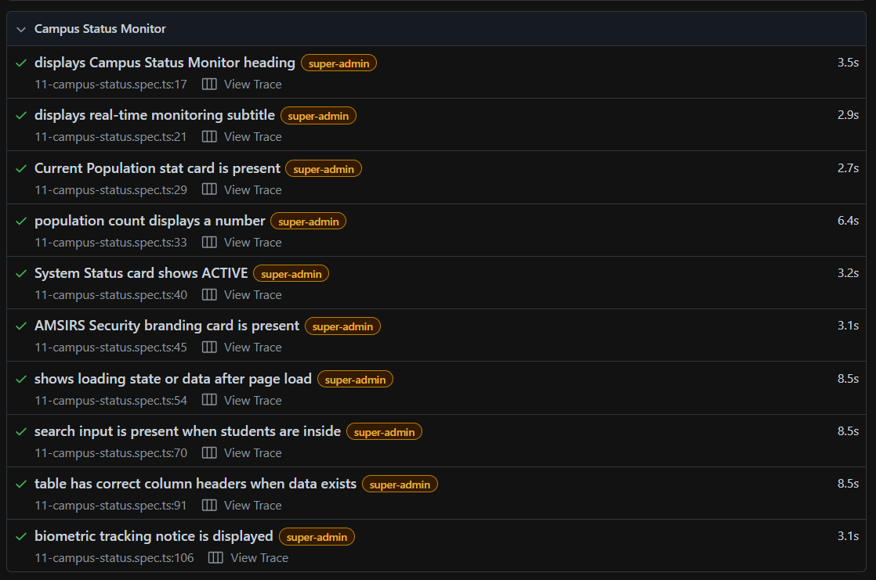
Figure 22. End-to-End Test Results of the Campus Status Monitor
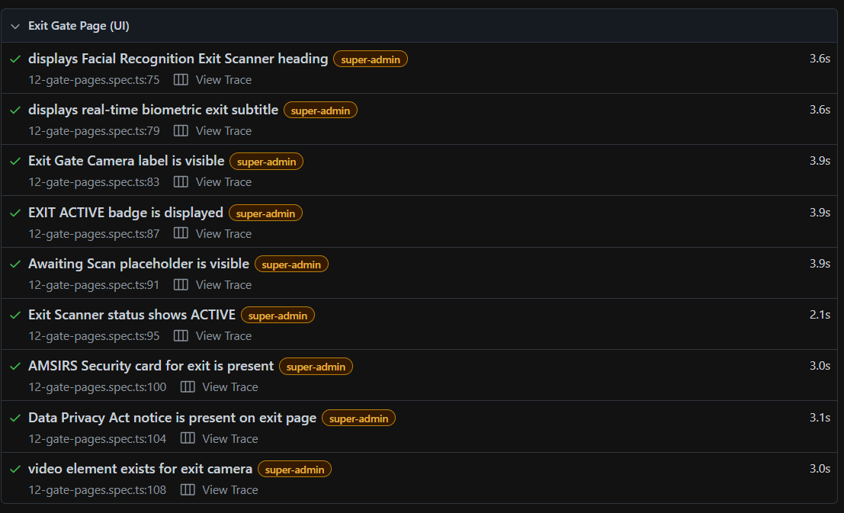
Figure 23. End-to-End Test Results of the Exit Gate Page (UI)
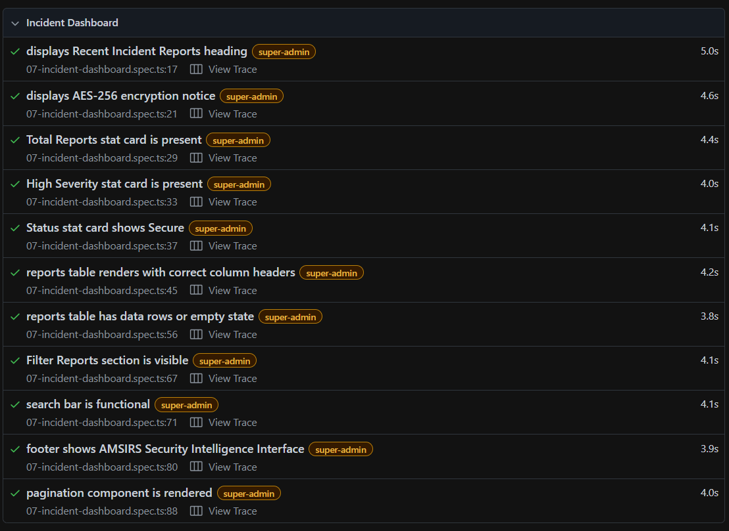
Figure 23. End-to-End Test Results of the Incident Dashboard

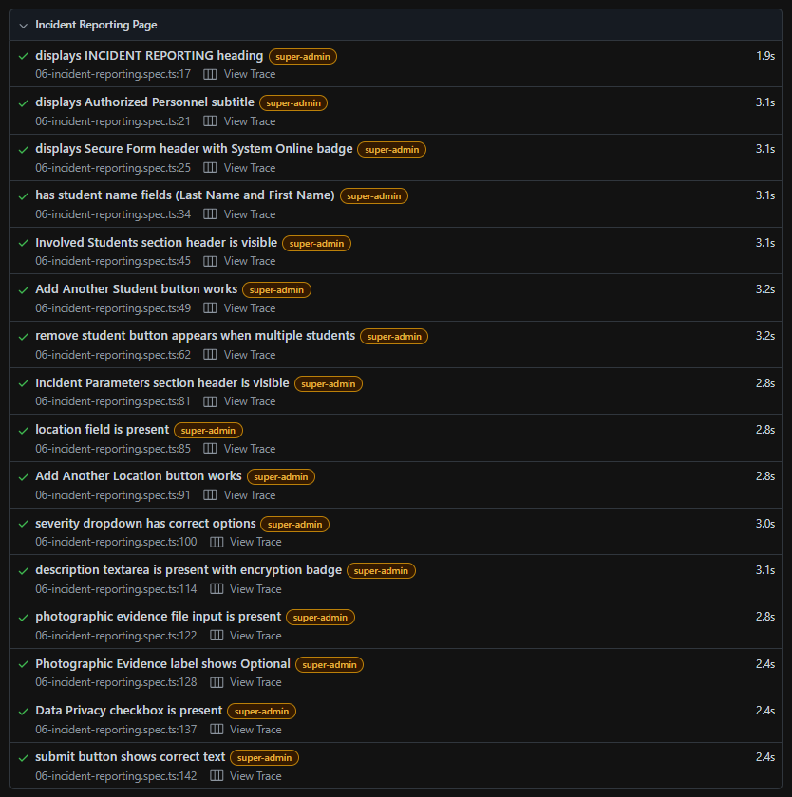
Figure 24. End-to-End Test Results of the Incident Reporting Page
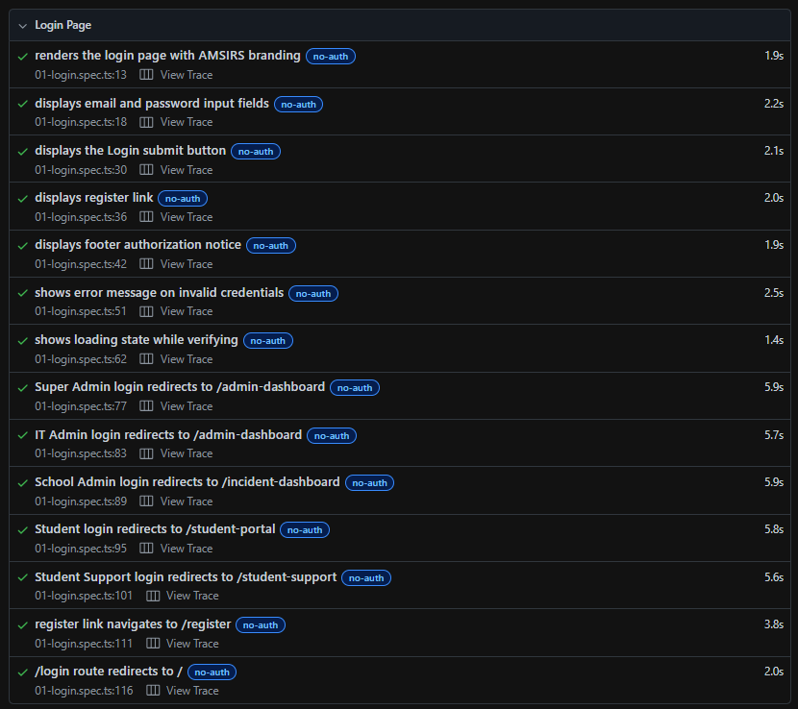
Figure 25. End-to-End Test Results of the Login Page
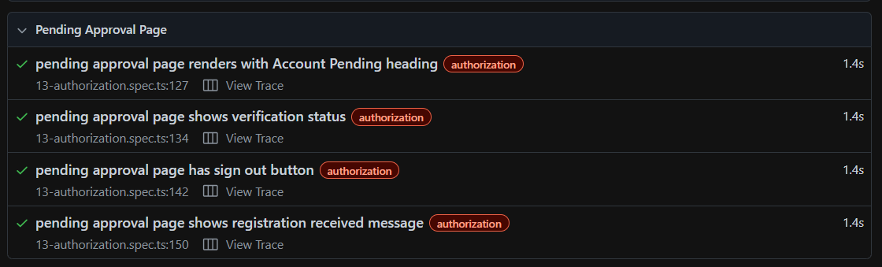
Figure 26. End-to-End Test Results of the Pending Approval Page
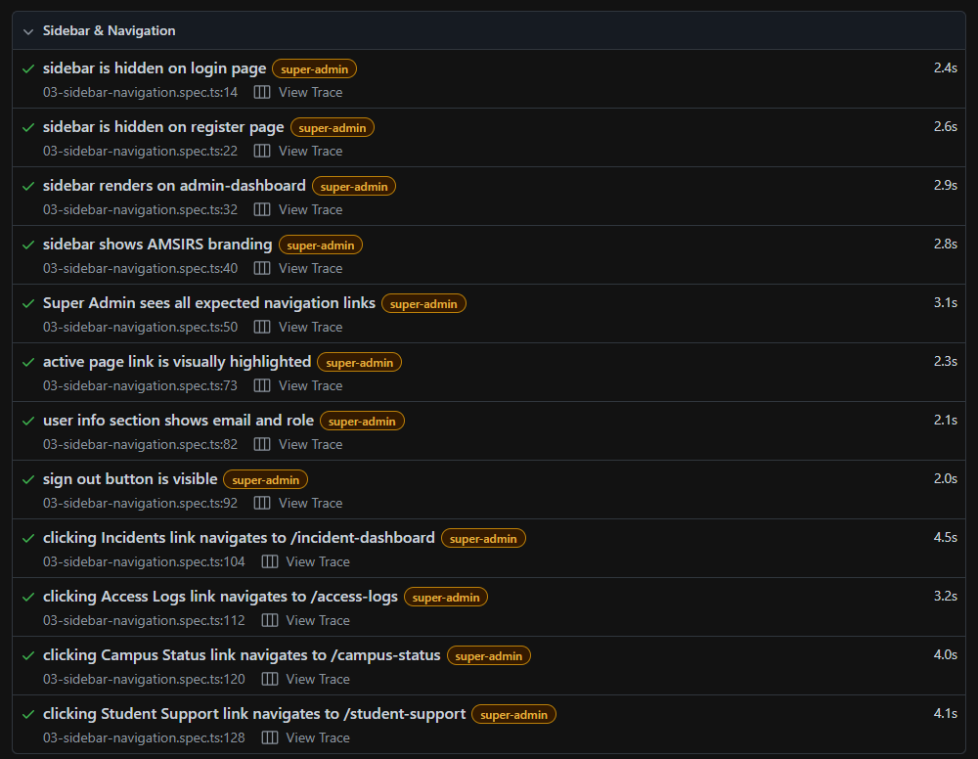
Figure 27. End-to-End Test Results of the Sidebar & Navigation

Figure 28. End-to-End Test Results of the Student Portal
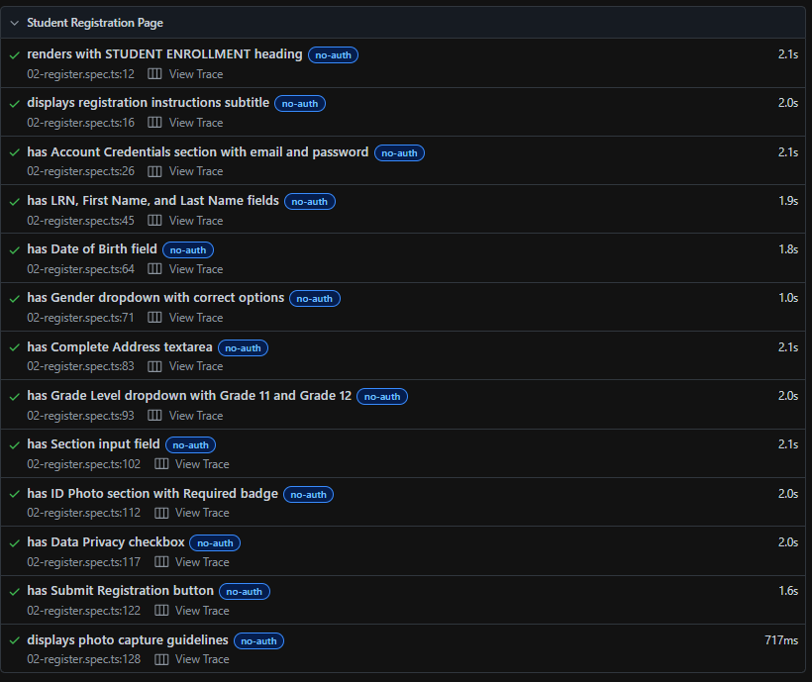
Figure 29. End-to-End Test Results of the Student Registration Page
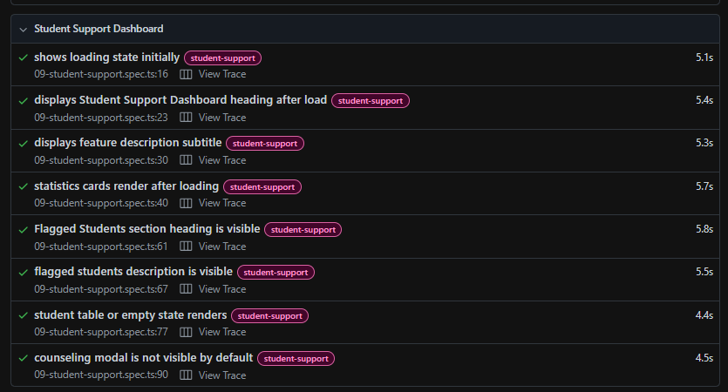
Figure 30. End-to-End Test Results of the Student Support Page
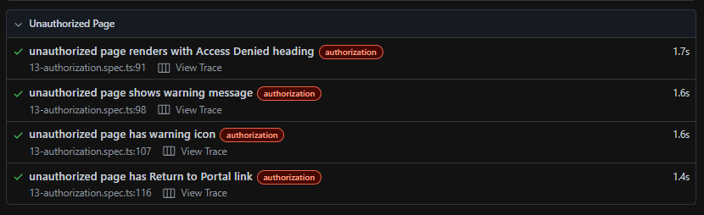
Figure 31. End-to-End Test Results of the Unauthorized Page
The preceding figures provide a visual confirmation of the system's interface integrity across critical operational pages, ranging from authentication portals to administrative dashboards. To supplement these visual validations with empirical evidence, the following table provides a comprehensive summary of all 169 automated test cases executed. This table details the specific functional modules evaluated, the descriptions of each test case, and their corresponding validation outcomes, offering a complete overview of the system's operational reliability.
Test Suite / Module | Test Case Description | Status
01-login | Render login page with AMSIRS branding | Passed
 | Display email and password input fields | Passed
 | Display the Login submit button | Passed
 | Display register link | Passed
 | Display footer authorization notice | Passed
 | Show error message on invalid credentials | Passed
 | Show loading state while verifying | Passed
 | Super Admin login redirect to /admin-dashboard | Passed
 | IT Admin login redirect to /admin-dashboard | Passed
 | School Admin login redirect to /incident-dashboard | Passed
 | Student login redirect to /student-portal | Passed
 | Student Support login redirect to /student-support | Passed
 | Register link navigation to /register | Passed
 | Redirect logic for root /login route | Passed
02-register | Render with STUDENT ENROLLMENT heading | Passed
 | Display registration instructions subtitle | Passed
 | Display Account Credentials section | Passed
 | Display LRN, First Name, and Last Name | Passed
 | Display Date of Birth field | Passed
 | Display Gender dropdown | Passed
 | Display Complete Address textarea | Passed
 | Display Grade Level dropdown | Passed
 | Display Section input field | Passed
 | Display ID Photo section with camera component | Passed
 | Display Data Privacy checkbox | Passed
 | Display Submit Registration button | Passed
 | Display photo capture guidelines | Passed
03-sidebar | Hide sidebar on login page | Passed
 | Hide sidebar on register page | Passed
 | Render sidebar on admin-dashboard | Passed
 | Show AMSIRS branding logo | Passed
 | Render Super Admin navigation links | Passed
 | Highlight active page link | Passed
 | Show user info section | Passed
 | Show sign out button | Passed
 | Navigate to /incident-dashboard | Passed
 | Navigate to /access-logs | Passed
 | Navigate to /campus-status | Passed
 | Navigate to /student-support | Passed
04-admin-dashboard | Display Root Control heading | Passed
 | Set staff tab active by default | Passed
 | Render student body tab as inactive | Passed
 | Render staff table headers | Passed
 | Populate staff table data | Passed
 | Display human-readable staff roles | Passed
 | Render staff status badges | Passed
 | Display Filter Directory header | Passed
 | Display role filter dropdown | Passed
 | Functioning search bar triggers filter | Passed
 | Display Create Staff button | Passed
 | Display Reset PW button per row | Passed
 | Render pagination section controls | Passed
 | Redirect unauthorized roles (School Admin blocked) | Passed
05-admin-dashboard | Activate Student Body tab styling | Passed
 | Render student table headers | Passed
 | Populate student table data | Passed
 | Render approval status badges | Passed
 | Display Filter Students header | Passed
 | Display grade filter dropdown | Passed
 | Functioning student search bar | Passed
 | Display Bulk Approve button | Passed
 | Display bulk approve instructions | Passed
 | Display Reset PW button per student | Passed
 | Display student edit buttons | Passed
 | Render student pagination section | Passed
06-incident-reporting | Display INCIDENT REPORTING heading | Passed
 | Display Authorized Personnel subtitle | Passed
 | Display Secure Form header & System Online | Passed
 | Render student name fields | Passed
 | Render Involved Students section | Passed
 | Dynamic Add Another Student | Passed
 | Dynamic remove student button | Passed
 | Render Incident Parameters section | Passed
 | Render location field | Passed
 | Dynamic Add Another Location | Passed
 | Severity dropdown options (Low, Medium, High) | Passed
 | Render encrypted description textarea | Passed
 | Render photographic evidence input | Passed
 | Display Optional label on evidence | Passed
 | Display Data Privacy checkbox | Passed
 | Display Submit Secured Report button | Passed
07-incident-dashboard | Display Recent Incident Reports heading | Passed
 | Display AES-256 encryption notice | Passed
 | Render Total Reports stat card | Passed
 | Render High Severity stat card | Passed
 | Render Status stat card | Passed
 | Render reports table headers | Passed
 | Populate reports table | Passed
 | Display Filter Reports section | Passed
 | Functioning search bar triggers location filter | Passed
 | Display footer intelligence text | Passed
 | Render pagination component | Passed
08-student-portal | Display STUDENT PORTAL heading | Passed
 | Display Personal Information subtitle | Passed
 | Render Identity Matrix card | Passed
 | Display Internal Database ID | Passed
 | Populate student name fields | Passed
 | Display LRN field | Passed
 | Display gender field | Passed
 | Display date of birth field | Passed
 | Display address field | Passed
 | Display grade level field | Passed
 | Display section field | Passed
 | Render profile photo area | Passed
 | Render Involvement Logs card | Passed
 | Display Encrypted badge on logs | Passed
 | Display mobile report responsive link | Passed
09-student-support | Render initial loading state | Passed
 | Display Dashboard heading post-load | Passed
 | Display feature description subtitle | Passed
 | Render statistics cards | Passed
 | Display Flagged Students heading | Passed
 | Display flagged students description | Passed
 | Render student table algorithms | Passed
 | Counseling modal hidden by default | Passed
10-access-logs | Display Access Logs heading | Passed
 | Display biometric records subtitle | Passed
 | Display Security Records heading | Passed
 | Render table column headers | Passed
 | Display Filter Security Records header | Passed
 | Functioning date filter dropdown | Passed
 | Functioning action filter dropdown | Passed
 | Render pagination buttons | Passed
 | Render log count display | Passed
 | Populate log table data | Passed
11-campus-status | Display Campus Status Monitor heading | Passed
 | Display real-time monitoring subtitle | Passed
 | Render Current Population stat card | Passed
 | Display numerical population count | Passed
 | Display System Status ACTIVE | Passed
 | Render AMSIRS Security branding card | Passed
 | Render loading state then data | Passed
 | Dynamic search input rendering | Passed
 | Display biometric tracking notice | Passed
12-gate-pages (Entry) | Display Entry Scanner heading | Passed
 | Display real-time biometric subtitle | Passed
 | Display Live Security Feed header | Passed
 | Display Entry Gate Camera label | Passed
 | Display LIVE badge | Passed
 | Display Awaiting Scan state | Passed
 | Render Identity Profile section | Passed
 | Display AI Monitoring ACTIVE status | Passed
 | Render AMSIRS Security branding card | Passed
 | Display Data Privacy Act notice | Passed
 | Validate WebRTC video element exists | Passed
12-gate-pages (Exit) | Display Exit Scanner heading | Passed
 | Display biometric exit subtitle | Passed
 | Display Exit Gate Camera label | Passed
 | Display EXIT ACTIVE badge | Passed
 | Display Awaiting Scan state | Passed
 | Display Exit Scanner ACTIVE status | Passed
 | Render AMSIRS Security card for exit | Passed
 | Display Data Privacy Act notice | Passed
 | Validate WebRTC video element exists | Passed
13-authorization | Protect /admin-dashboard from guests | Passed
 | Protect /incident-dashboard from guests | Passed
 | Protect /student-portal from guests | Passed
 | Protect /admin-dashboard from students | Passed
 | Protect /access-gate from students | Passed
 | Protect /admin-dashboard from School Admins | Passed
 | Render Access Denied heading | Passed
 | Display authorization warning message | Passed
 | Render unauthorized warning icon | Passed
 | Display Return to Portal link | Passed
 | Render Account Pending heading | Passed
 | Display verification status | Passed
 | Display pending page sign out button | Passed
 | Display registration received message | Passed

Table 7. Comprehensive Test Execution Results

As demonstrated in Table 7, the testing phase resulted in a 100% Pass Rate across all 169 evaluated parameters. The success of Suite 13 (Authorization) is significant, as it proves that the system's security architecture — specifically the Next.js middleware and Supabase session management — is robust enough to prevent unauthorized horizontal and vertical access manipulation. Furthermore, the successful passing of Suite 06 (Incident Reporting) and Suite 09 (Student Support) validates the system's core algorithmic workflow: secure data entry forms generate the requisite data payloads, which correctly trigger UI responses on the counselor's dashboard.

4.2 Cross-Browser Compatibility Testing
Cross-browser compatibility testing was conducted to evaluate the ability of AMSIRS to function consistently across different web browsers. Since users may access the system using various browser platforms, it is important to ensure that all system features, user interfaces, and functionalities operate correctly regardless of the browser being used. Compatibility testing helps identify potential issues related to browser rendering, interface responsiveness, navigation, and feature execution that may affect the overall user experience [61].
The testing was performed using BrowserStack, which provided access to real browser environments for validation. Key functionalities evaluated during testing included user authentication, attendance monitoring, incident reporting, student support services, dashboard visualization, report generation, navigation components, and responsive layouts. Table 8 presents the results of the cross-browser compatibility testing conducted on the supported web browsers.
Browser | Login | Incident Reporting | Dashboard | Result
Chrome | Pass | Pass | Pass | Passed
Edge | Pass | Pass | Pass | Passed
Firefox | Pass | Pass | Pass | Passed
Safari | Pass | Pass | Pass | Passed
Table 8. Browsers Used for Cross-Browser Compatibility Testing

Google Chrome:
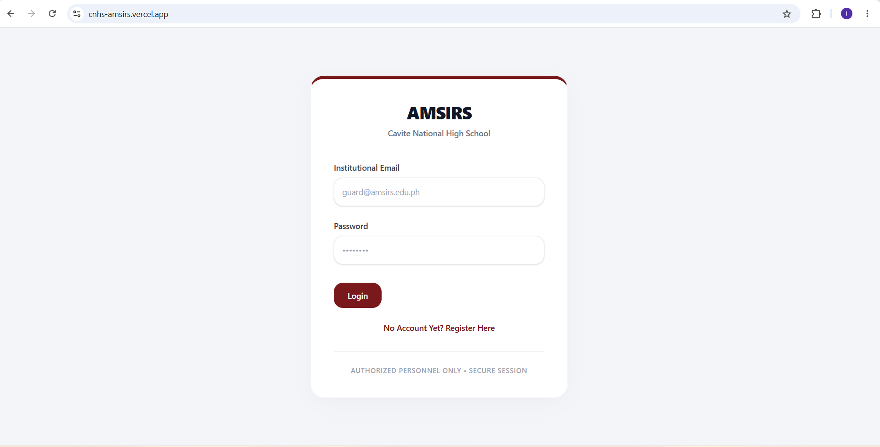
Figure 32. Picture of Login Interface of AMSIRS using Google Chrome
Opera:
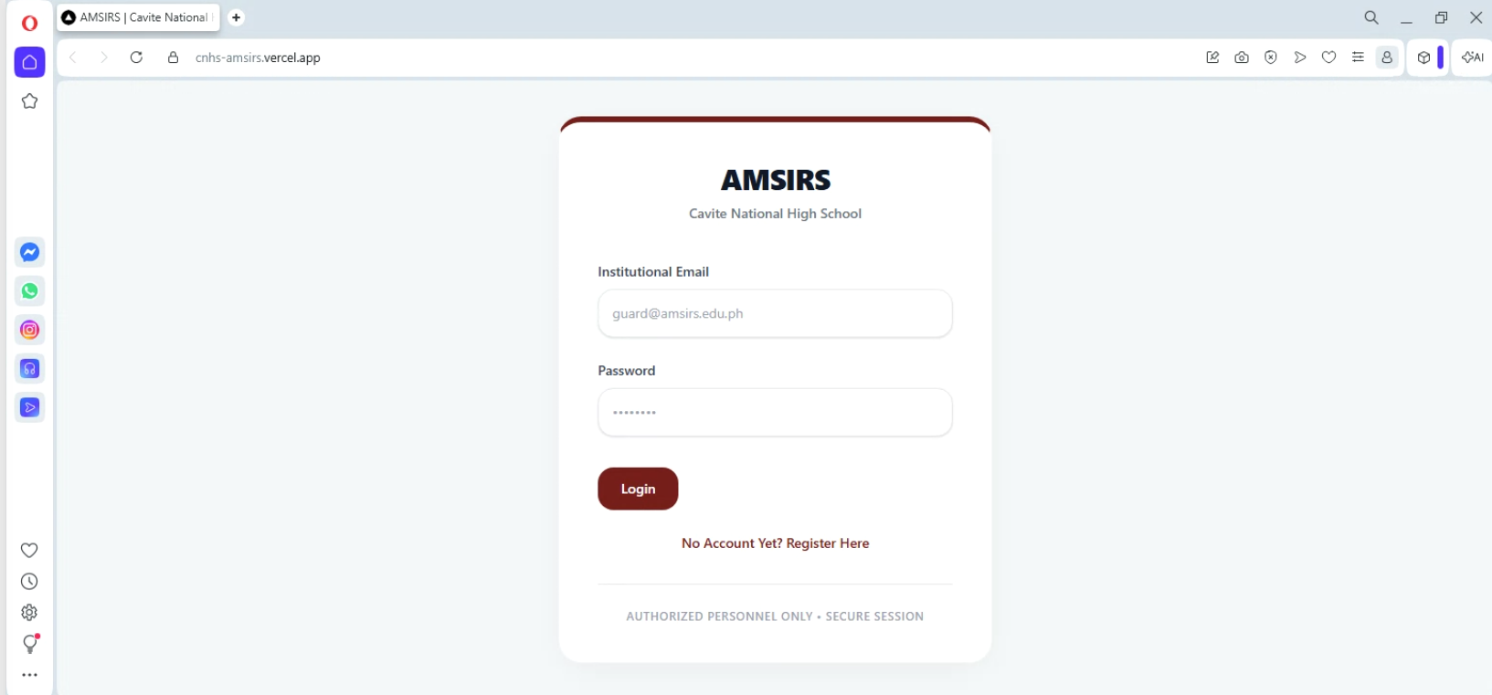
Figure 33. Picture of Login Interface of AMSIRS using Opera

Firefox:
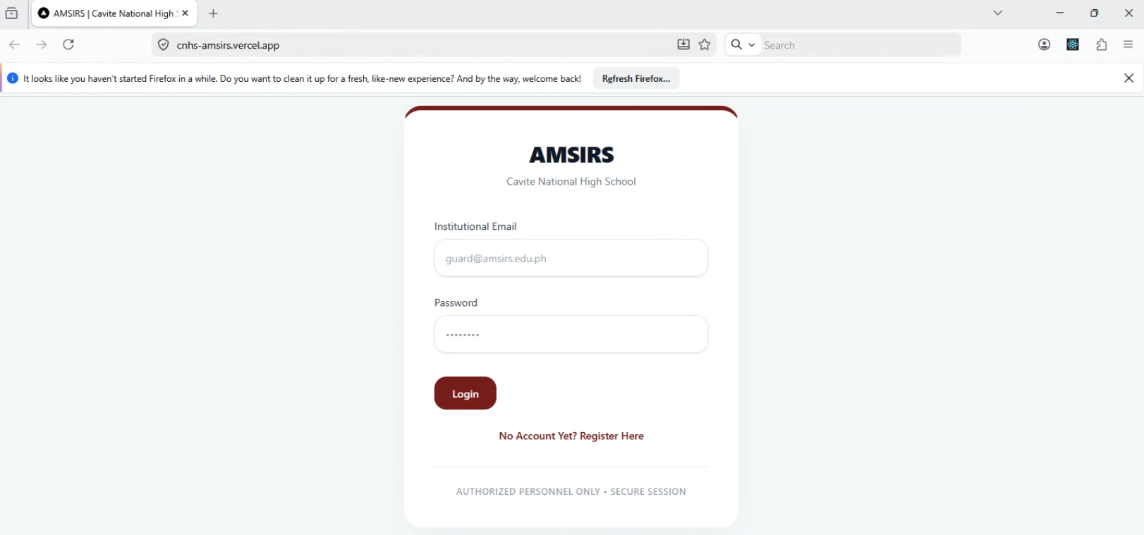
Figure 34. Picture of Login Interface of AMSIRS using Firefox
Safari:
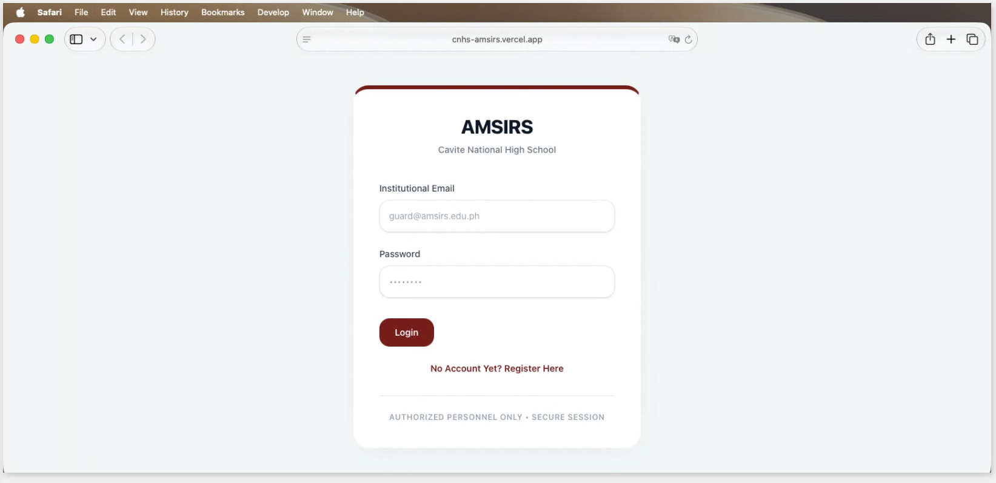
Figure 35. Picture of Login Interface of AMSIRS using Safari

Edge:
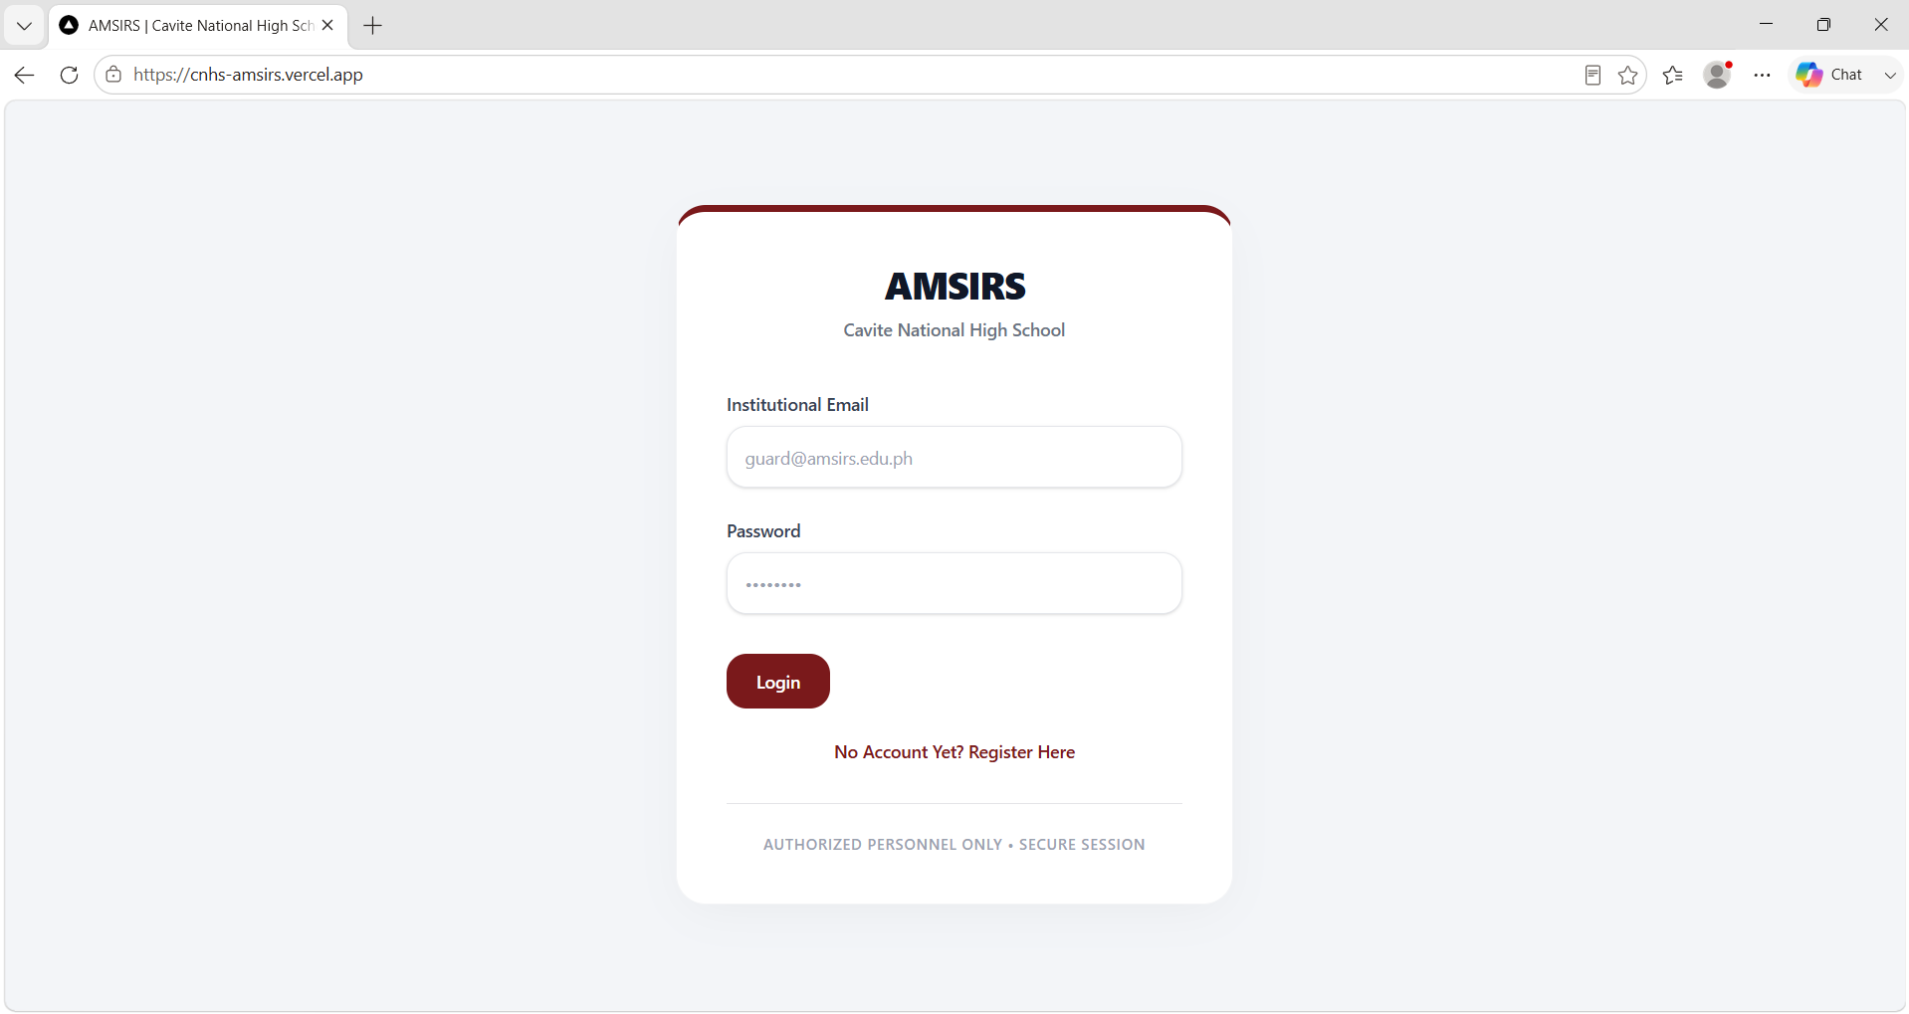
Figure 36. Picture of Login Interface of AMSIRS using Microsoft Edge

4.2.1 Discussion of Cross-Browser Compatibility Testing Results
The results presented in Table 8 indicate that AMSIRS successfully operated across all tested web browsers, including Google Chrome, Microsoft Edge, Mozilla Firefox, and Safari. All major functionalities, such as user authentication, access monitoring, incident reporting, dashboard visualization, and report generation, performed as expected without any significant compatibility issues.

The successful execution of system functions across multiple browsers demonstrates that AMSIRS is capable of providing a consistent user experience regardless of the browser platform used. This finding supports the importance of compatibility testing in ensuring software reliability and accessibility, as different browsers may utilize varying rendering engines that can affect application behavior [61].
Furthermore, the results suggest that the web technologies and frameworks utilized in the development of AMSIRS were implemented according to modern web standards, enabling the system to maintain consistent functionality and interface presentation across different browser environments. The successful compatibility across all tested browsers indicates that users can access the system without experiencing browser-specific limitations that could negatively impact system usability and operational efficiency.

4.3 Device Compatibility Testing
Device compatibility testing was conducted to determine whether AMSIRS can effectively operate across different device types and operating systems. As a web-based system intended for use by administrators, security personnel, guidance personnel, and students, ensuring compatibility across desktop and mobile platforms is essential for maintaining accessibility and usability. Device compatibility testing evaluates the responsiveness, functionality, and interface adaptability of the system under different hardware and software environments [62].
BrowserStack was utilized to test AMSIRS on various device configurations, including desktop computers, smartphones, and tablets running different operating systems. Critical system functions such as login authentication, attendance monitoring, incident reporting, dashboard access, and report generation were assessed to verify consistent performance and user experience across all tested devices. Table 9 presents the results of the device compatibility testing.

Device | OS | Responsive Layout | Functionality | Result
Samsung Galaxy S25 | Android 15 | Pass | Pass | Passed
Samsung Galaxy Tab S10+ | Android 15 | Pass | Pass | Passed
iPhone 17 Pro Max | iOS 26 | Pass | Pass | Passed
iPad Pro 13 2025 | iPadOS 18 | Pass | Pass | Passed
Table 9. Device Used for Device Compatibility Testing

Iphone 15 Pro Max:
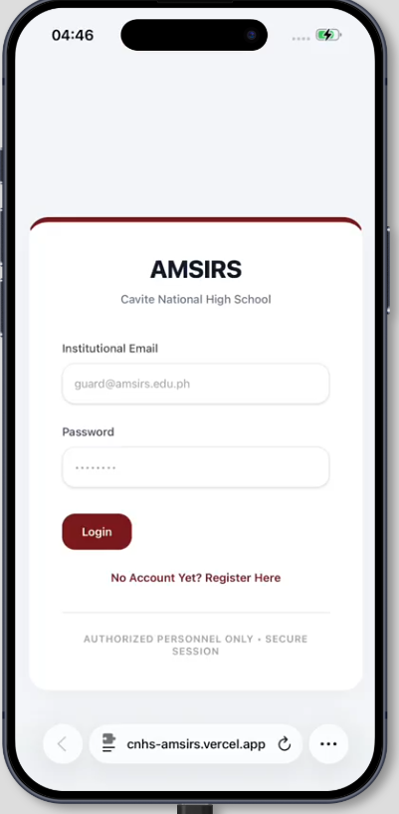
Figure 37. Picture of Login Interface of AMSIRS using Iphone 15 Pro Max

Samsung S25:
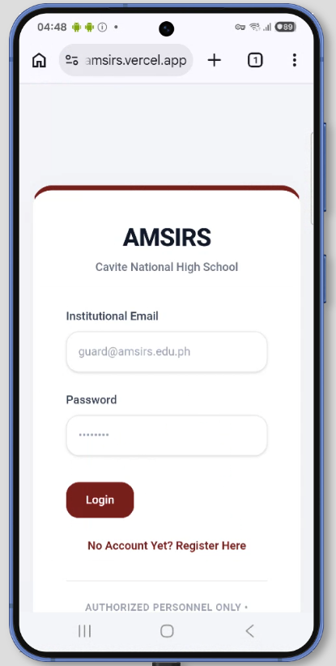
Figure 38. Picture of Login Interface of AMSIRS using Samsung Galaxy S25

Samsung Galaxy Tab S10+:
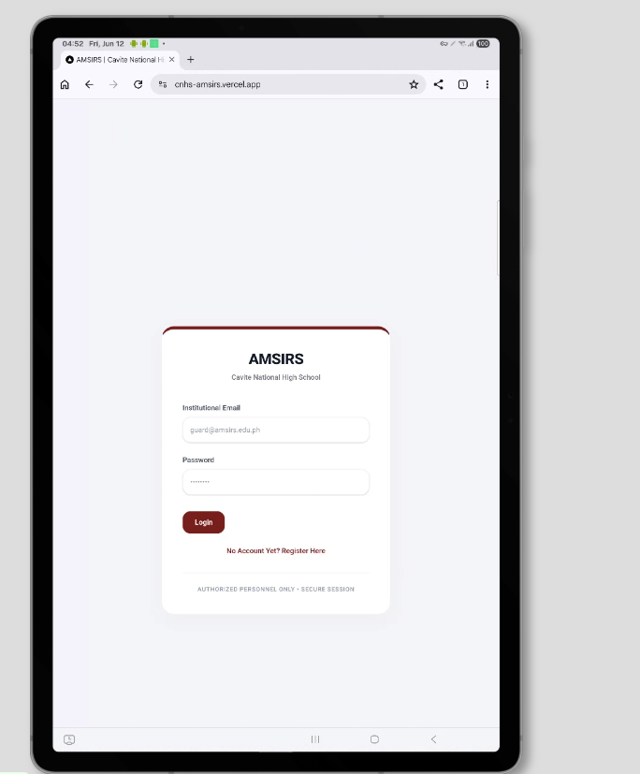
Figure 39. Picture of Login Interface of AMSIRS using Samsung Galaxy Tab S10+

iPad Pro 13 2025:

Figure 40. Picture of Login Interface of AMSIRS using iPad Pro 13 2025

4.3.1 Discussion of Device Compatibility Testing Results
The results shown in Table 4.3 demonstrate that AMSIRS successfully operated across all tested devices and operating systems. The system maintained proper responsiveness, functionality, and interface consistency on desktop computers, Android smartphones, iPhones, and tablet devices. Core functionalities, including login authentication, attendance monitoring, incident reporting, dashboard accessibility, and report generation, were accessible and fully operational on all tested platforms.
The successful device compatibility testing indicates that AMSIRS can effectively support users who access the system using different devices and screen sizes. This finding aligns with the recommendations of Al-Azawei et al. [62], who emphasized that educational information systems should maintain usability and accessibility across multiple technological environments to accommodate diverse user needs.
The results further demonstrate the effectiveness of the system's responsive design implementation, allowing interface elements and navigation components to adapt appropriately to different display resolutions and device specifications. Consequently, AMSIRS provides a consistent and accessible user experience across desktop and mobile platforms, supporting its intended use by administrators, security personnel, guidance personnel, and students.
4.4 Performance Testing
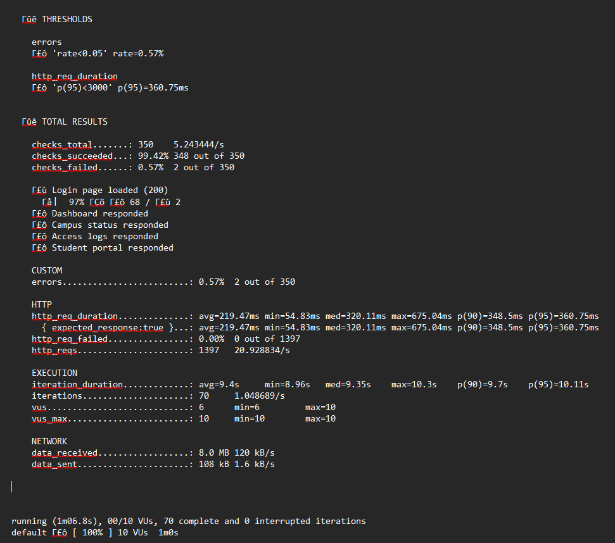
Performance testing was conducted to evaluate the responsiveness, stability, and scalability of AMSIRS under varying levels of concurrent user activity. As a web-based system intended for simultaneous use by administrators, security personnel, guidance counselors, and students, it is essential that the system maintains acceptable response times during peak operational periods, such as morning entry rushes at the campus gate or simultaneous incident submission events [63]. Using k6, a modern open-source load testing framework by Grafana, three load scenarios were simulated against the deployed AMSIRS production environment hosted on Vercel: a Low Load scenario with 10 concurrent virtual users, a Medium Load scenario with 25 concurrent virtual users, and a High Load scenario with 50 concurrent virtual users. Each scenario ran for a duration of 60 seconds, during which virtual users repeatedly sent HTTP requests to five core system endpoints: the Login page, the Incident Dashboard, the Campus Status Monitor, the Access Logs page, and the Student Portal. Key performance metrics captured include average response time, minimum and maximum response times, the 95th percentile response time (p95), throughput measured in requests per second, and the HTTP failure rate. Table 10 presents the consolidated results across all three scenarios.

Figure 41. k6 Performance Test Output — Low Load (10 Concurrent Users)
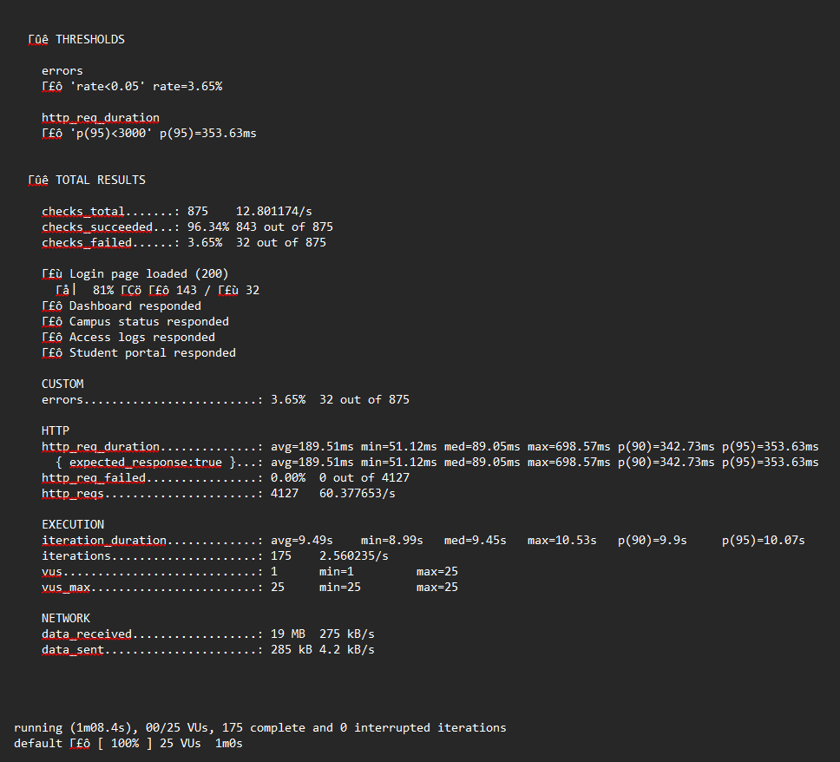
Figure 42. k6 Performance Test Output — Medium Load (25 Concurrent Users)
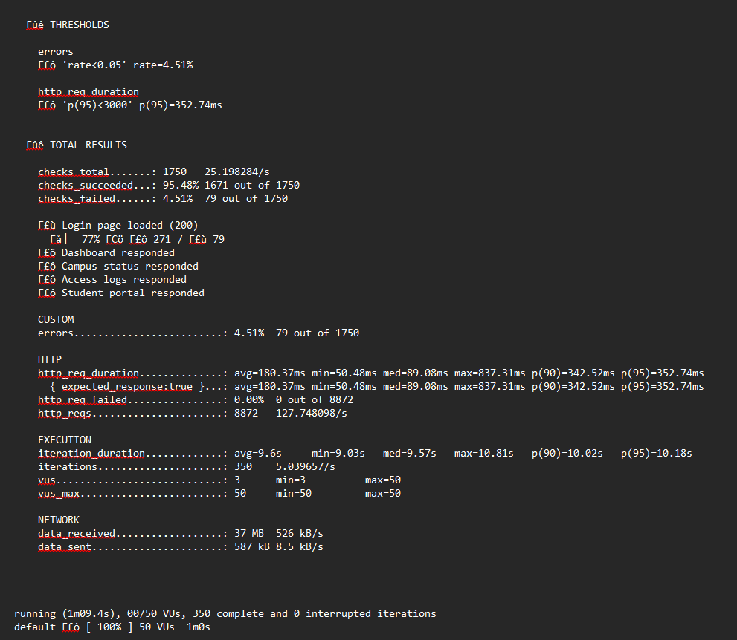
Figure 43. k6 Performance Test Output — High Load (50 Concurrent Users)
Scenario | Concurrent Users | Total Requests | Avg Response Time (ms) | Min (ms) | Max (ms) | p(95) (ms) | Throughput (req/s) | HTTP Failure Rate
Low Load | 10 | 1,397 | 219.47 | 54.83 | 675.04 | 360.75 | 20.93 | 0.00%
Medium Load | 25 | 4,127 | 189.51 | 51.12 | 698.57 | 353.63 | 60.38 | 0.00%
High Load | 50 | 8,872 | 180.37 | 50.48 | 837.31 | 352.74 | 127.75 | 0.00%
Table 10. Performance Testing Results

4.4.1 Discussion of Performance Testing Results
The results presented in Table 10 demonstrate that AMSIRS maintained strong performance stability and reliability across all three load scenarios. The most critical finding is that the HTTP failure rate remained at 0.00% throughout every scenario, indicating that no server-level errors occurred regardless of user load. This confirms that the underlying Vercel serverless infrastructure and Supabase PostgreSQL cloud database were capable of handling all concurrent requests without dropping a single connection or returning a 5xx server error, demonstrating the robustness of the system’s cloud-native architecture.
Regarding average response times, the data reveals a decreasing trend as concurrent load increased, from 219.47ms under low load to 189.51ms under medium load and 180.37ms under high load. This behavior is attributable to the performance characteristics of Vercel’s Edge Network and Next.js serverless runtime. Under sustained and increasing concurrent load, a greater proportion of requests encounter already-active serverless function instances rather than cold-start instances, and the CDN cache warms up with frequently accessed routes, resulting in faster average response delivery. This pattern is consistent with the behavior described by Sharma and Kumar [63] regarding scalable web-based systems deployed on modern cloud platforms. The maximum response time did increase progressively across scenarios, from 675.04ms under low load to 837.31ms under high load; however, all values remained well within the 3,000ms acceptance threshold defined for this study.
The 95th percentile (p95) response time was remarkably consistent across all three scenarios, measuring 360.75ms, 353.63ms, and 352.74ms for the low, medium, and high load conditions respectively. This stability in the p95 metric is significant, as it indicates that even the slowest 5% of requests experienced only marginal differences in response duration under increasing load. A stable p95 value is a strong indicator that the system does not exhibit performance degradation at the tail end of the request distribution, confirming predictable response behavior for all user roles regardless of system load [63].
Throughput scaled proportionally with the number of concurrent virtual users, increasing from 20.93 requests per second under low load to 60.38 under medium load and 127.75 under high load. This near-linear increase confirms that the AMSIRS platform does not exhibit architectural bottlenecks within the tested load range, and that the serverless deployment model supports the horizontal scalability necessary for an institutional environment where multiple user roles may access the system simultaneously during peak periods.
A small proportion of check-level failures were recorded on the Login page endpoint across the three scenarios: 0.57% under low load, 3.65% under medium load, and 4.51% under high load. It is important to note that these failures are not server errors, as confirmed by the concurrent http_req_failed rate of 0.00%. Rather, they reflect the expected behavior of the Next.js authentication middleware, which issues HTTP 307 redirect responses to unauthenticated access attempts in order to enforce role-based access control. Under higher concurrency, this redirect chain behavior was encountered more frequently due to the increased rate of simultaneous unauthenticated requests, which is consistent with the system’s designed security posture. All other tested modules — the Incident Dashboard, Campus Status Monitor, Access Logs, and Student Portal — recorded a 100% successful response rate across all three load scenarios.
All predefined performance thresholds were satisfied across every load scenario: the p95 response time remained well below the 3,000ms ceiling, and the error rate did not exceed the 5% maximum allowance. These results indicate that AMSIRS is capable of delivering responsive, reliable, and scalable performance appropriate for its intended deployment at Cavite National High School, supporting concurrent access by its target user population without degradation in system functionality or user experience.

Chapter 5
CONCLUSION AND RECOMMENDATION
5.1 Conclusion
This study successfully designed, developed, and evaluated the Web-Based Integrated Institutional System for Access Monitoring, Safety Incident Reporting, and Student Support (AMSIRS). The system was created to address the fragmented and manual processes currently used in managing attendance records, safety incident reports, and student support services at Cavite National High School – Senior High School.
The findings of the study demonstrate that AMSIRS effectively integrates these previously independent operational domains into a centralized web-based platform. Through the implementation of facial recognition-based access monitoring, digital incident reporting, and a unified student support module, the system provides real-time data accessibility and improves institutional coordination.
The results of the End-to-End testing showed a 100% pass rate across 169 automated test cases, confirming the functional reliability and stability of the system. Cross-browser compatibility testing further verified that AMSIRS operates consistently across major web browsers, while device compatibility testing demonstrated successful operation on desktop computers, smartphones, and tablets. Performance testing also revealed that the system maintained stable response times, acceptable error rates, and scalable throughput under varying levels of concurrent user activity.
Based on these findings, the study concludes that AMSIRS successfully achieved its objectives of reducing information silos, improving operational efficiency, supporting proactive student intervention, and providing a reliable platform for institutional management. The developed system offers a practical and scalable solution that can assist educational institutions in modernizing administrative processes while enhancing campus safety and student welfare.
5.2 Recommendations
Based on the findings and limitations of the study, the following recommendations are proposed:
- Future researchers may conduct large-scale deployment and evaluation of AMSIRS in multiple educational institutions to further assess scalability, reliability, and long-term usability.
- The face recognition module may be enhanced through the implementation of anti-spoofing mechanisms, liveness detection, and advanced deep learning models to improve security and recognition accuracy under varying environmental conditions.
- Additional analytics and predictive monitoring features may be integrated to assist administrators and guidance counselors in identifying students who may require early intervention based on attendance patterns and incident histories.

- Educational institutions intending to adopt AMSIRS should establish clear policies regarding biometric data collection, privacy protection, data retention, and user consent to ensure compliance with the Data Privacy Act of 2012 and other applicable regulations.

APPENDICES
APPENDIX A

APPENDIX B

APPENDIX C
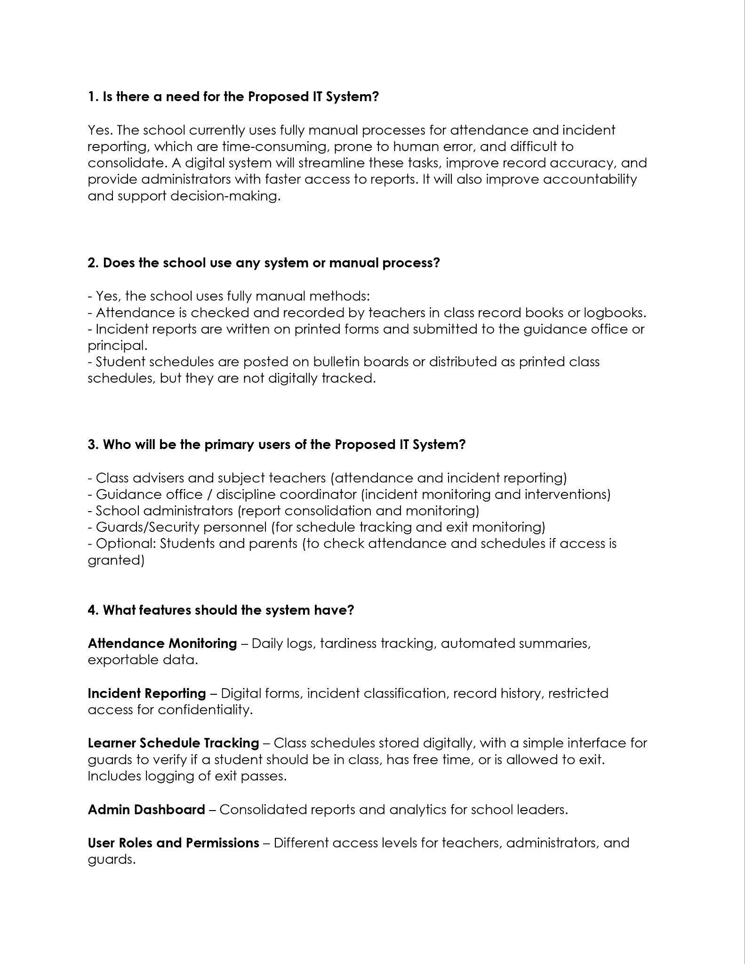

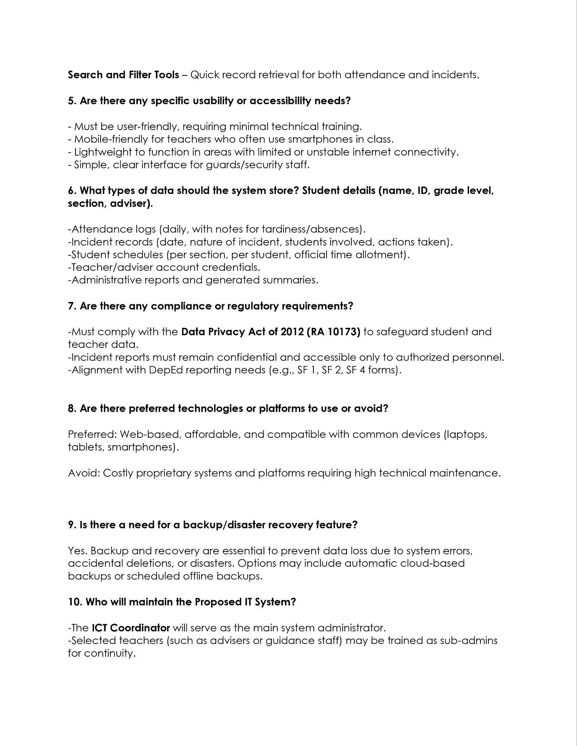

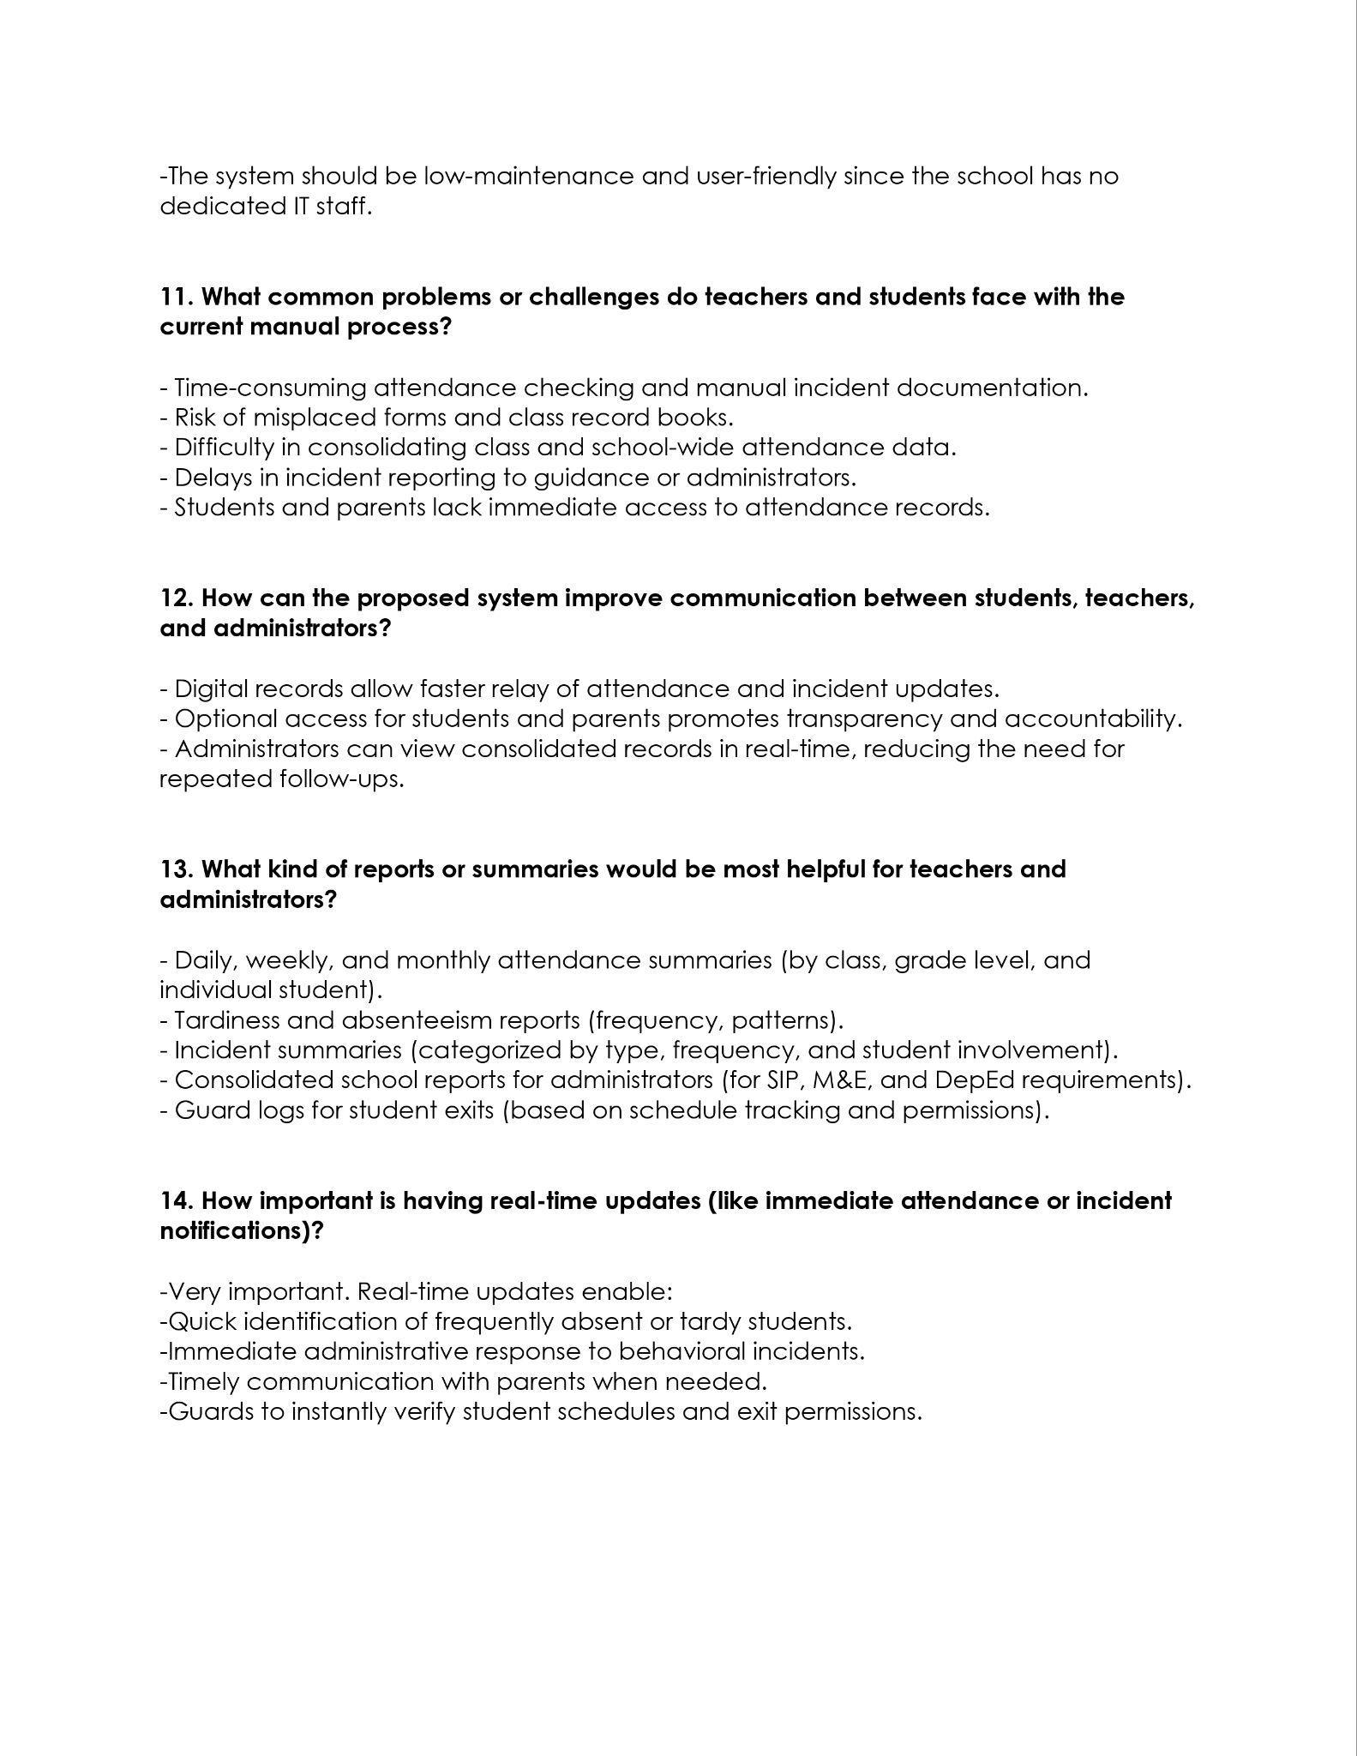



REFERENCES
[1] Shalini, L., 2025. Why universities should invest in an integrated campus management solution. Retrieved October 12, 2025, from https://elearningindustry.com/why-universities-should-invest-in-an-integrated-campus-management-solution
[2] American Institutes for Research (AIR). (2025). Case Study of Coordinating Integrated Student Supports and Expanded Learning Opportunities. American Institutes for Research. Retrieved from https://www.air.org/sites/default/files/2025-05/Case-Study-Coordinating-ISS-Expanded-Learning-Opportunities-May-2025.pdf
[3] Ravi Chandra, M. L., et al. (2025). Student Monitoring System Using AI and Image Processing. Journal of Ubiquitous Computing and Communication Technologies, 7(4), 375-393. DOI: 10.36548/jucct.2025.4.004
[4] Bellevue College. (2021). Integrated Student Support Redesign Toolkit: Designing Holistic Student Supports. Achieving the Dream (ATD). Retrieved from https://www.bellevuecollege.edu/atd/wp-content/uploads/sites/404/2021/06/atd_integrated_student_support_toolkit_2.0.pdf
[5] U.S. Department of Education. (2023). Guiding Principles for Creating Safe, Inclusive, Supportive, and Fair School Climates. Washington, D.C. Retrieved from https://www.ed.gov/sites/ed/files/policy/gen/guid/school-discipline/guiding-princples.pdf
[6] Othman, A., et al. 2024. Biometric Breakthroughs for Sustainable Travel: Transforming Public Transportation through Secure Identification. MDPI., from https://doi.org/10.3390/su16125071
[7] Konda, R. 2023. AI-Based Security Surveillance Systems for Enhancing Public Transportation Safety., from https://doi.org/10.5281/zenodo.15349607
[8] R. Mirza et al. 2025. Facial Recognition in Transportation System to Boost Students’ Safety (iSee System)., from https://doi.org/10.18421/TEM142-1
[9] Chakraborty, S., et al. 2026. A Comprehensive Review on Smart Attendance System., from https://doi.org/10.1109/ICCCES62661.2026.11437131
[10] Panchbhai, V., et al. 2024. Smart Attendance System: An Internet of Things (IoT)-Enabled Concept. Cureus., from https://doi.org/10.7759/s44389-024-00164-z
[11] Mr, Arul Selvan M, Mrs. Vardhini, "IMPACT OF DIGITAL ATTENDANCE SYSTEM ON STUDENT PERFORMANCE AND DISCIPLINE," International Advanced Research Journal in Science, Engineering and Technology (IARJSET), DOI: 10.17148/IARJSET.2025.125161
[12] Target Integration. 2023. 5 reasons to avoid using disparate systems for your business., from https://targetintegration.com/en_gb/5-reasons-why-you-must-avoid-disparate-systems/
[13] KlassApps. 2023. How integrated systems can streamline college administration. From https://klassapps.com/how-integrated-systems-can-streamline-college-administration/
[14] ITConvergence. 2023. Steps to define scope of an integration project. From https://www.itconvergence.com/blog/how-to-define-the-scope-of-your-integration-project
[15] MultiShoring. 2023. 10 main steps in the system integration process. From https://multishoring.com/blog/10-step-system-integration-process-why-integration-methodology-matters/
[16] Atlassian. 2023. How to define & write a project scope | The Workstream. From https://www.atlassian.com/work-management/project-management/project-scope
[17] M. H. Siddiqui, H. Pednekar, P. Sakat, and A. Q. Qureshi, "Facial Recognition-Based Attendance System," Research Proposal, Apr. 2024, DOI: 10.13140/RG.2.2.20991.21921.
[18] K. Alhanaee, M. Alhammadi, N. Almenhali, and M. Shatnawi, "Face Recognition Smart Attendance System using Deep Transfer Learning," Procedia Computer Science, vol. 192, pp. 4093-4102, 2021, DOI: 10.1016/j.procs.2021.09.184.
[19] Archana S. Nadhan, Chetana Tukkoji, Boosi Shyamala, N. Dayanand Lal, A. N. Sanjeev Kumar, V. Mohan Gowda, Zameer Ahmed Adhoni, and Melaku Endaweke. 2022. Smart Access Monitoring Technology for Industry 4.0. Journal of Nanomaterials 2022 (June 2022), 1–9. DOI:https://doi.org/10.1155/2022/4899768
[20] Mary Ann E. Ignaco. 2021. Mobile Application for Incident Reporting. International Journal on Informatics Visualization 5, 4 (December 2021), 388–394. DOI:https://dx.doi.org/10.30630/joiv.5.4.741
[21] R. Sabharwal and S. J. Miah, "A new theoretical understanding of big data analytics capabilities in organizations: A thematic analysis," Journal of Big Data, vol. 8, no. 159, 2021. DOI: 10.1186/s40537-021-00543-6.
[22] T. McClain, "Data Analysis & Reporting," Office of Research and Strategic Initiatives, 2021.
[23] L. Nong, G. Liu, C. Tang, and Y. Chen, "The Design and Implementation of Campus Informatization in Chinese Universities: A Conceptual Framework," Sustainability, vol. 15, no. 6, p. 4732, 2023. DOI: 10.3390/su15064732.
[24] B. G. S. Grepon, N. T. Baran, K. M. V. C. Gumonan, A. L. M. Martinez, and M. L. E. Lacsa, "Designing and Implementing e-School Systems: An Information Systems Approach to School Management of a Community College in Northern Mindanao, Philippines," arXiv preprint arXiv:2109.00198, 2021.
[25] Aris Setyo Radyawanto and Dwi Soediantono. 2022. Literature Review of Integrated Management System (IMAS) and Implementation Suggestion in the Defense Industry. International Journal of Social and Management Studies (IJOSMAS), 3, 3 (2022), 39-49. DOI: 10.5555/ijosmas.v3i3.141
[26] S. Ahmady, Z. Khoshgoftar, E. Toofaninejad, S. Sohrabi, M. Kalantarion, and O. Simpson. 2023. Identifying dimensions and components of student support system in virtual learning: A scoping review. In Journal of Education and Health Promotion (JEHP). Volume 12. Wolters Kluwer - Medknow. DOI: 10.4103/jehp.jehp_146_23.
[27] X. Lv and M. Li. 2021. Application and research of the intelligent management system based on Internet of Things technology in the era of big data. Mobile Information Systems, 2021, 1–6. ResearchGate. https://doi.org/10.1155/2021/6515792
[28] M. C. Abejo. 2023. Enterprise Resource Planning (ERP) System Implementation Framework for Selected State Universities. SSOAR. https://www.ssoar.info/ssoar/handle/document/90576
[29] Y. Liu, "Design and Implementation of a Student Attendance Management System based on Springboot and Vue Technology," Frontiers in Computing and Intelligent Systems, vol. 8, no. 1, pp. 91-97, 2024.
[30] M. H. Alkawaz, K. Alagasan, A. I. Hajamydeen, and M. N. Mohammed, "A Review Paper on Advanced Attendance and Monitoring Systems," in Proc. IEEE 12th Control and System Graduate Research Colloquium (ICSGRC), Shah Alam, Malaysia, 2021, pp. 194-199, doi: 10.1109/ICSGRC53186.2021.9515249.
[31] K. Ishaq and S. Bibi, "IoT Based Smart Attendance System Using RFID: A Systematic Literature Review," arXiv preprint arXiv:2308.02591, 2023.
[32] M. F. Naen, M. H. M. Adnan, N. A. Yazi, and C. K. Nee, "Development of Access Monitoring System with Artificial Intelligence Optimization in Cloud," International Journal of Artificial Intelligence, vol. 8, no. 2, pp. 88-98, Dec. 2021.
[33] A. Touzene, A. W. Abed, and S. Larabi, "An Embedded Intelligent System for Access Monitoring," arXiv preprint arXiv:2406.13694, 2024.
[34] T.-W. Chiang et al., "Development and Evaluation of an Attendance Tracking System Using Smartphones with GPS and NFC," Applied Artificial Intelligence, vol. 36, no. 1, p. 2083796, 2022, doi: 10.1080/08839514.2022.2083796.
[35] Yuchen Zhang, Christine Yip, Erwan Lu, and Z. Y. Dong. 2022. A Systematic Review on Technologies and Applications in Smart Campus: A Human-Centered Case Study. ResearchGate. https://doi.org/10.1109/ACCESS.2022.3148735
[36] Elizabeth Messman, Justin Heinze, Hsing-Fang Hsieh, Nicole Hockley, Naomi Pomerantz, Alison Grodzinski, Briana Scott, Noah Goldstein, and Marc Zimmerman. 2021. Anonymous Reporting Systems for School-Based Violence Prevention: A Systematic Review. SAGE Journals. https://doi.org/10.1177/10901981211073734
[37] Ahmad Anshari, Sulistyo Aris Hirtranusi, Dana Indra Sensuse, Kautsarina, and Ryan Randy Suryono. 2021. Face Recognition for Identification and Verification in Attendance System: A Systematic Review. IEEE Xplore. http://dx.doi.org/10.1109/COMNETSAT53002.2021.9530817
[38] Li Xiaomeng. 2021. Integrating Big Data Intelligence into K-12 Schools Campus Safety Management. FrancisPress, Vol. 6. https://doi.org/10.25236/FER.2023.063004
[39] Johnson Sirleaf Brisbane. 2024. Enhancing School Security System Using RFID: A Comprehensive Approach. International Scientific Journal of Engineering and Management. http://dx.doi.org/10.55041/ISJEM01380
[40] Chiara Ceccarini, Silvia Mirri, Paola Salomoni, and Catia Prandi. 2021. On Exploiting Data Visualization and IoT for Increasing Sustainability and Safety in a Smart Campus.ResearchGates, October 2021. https://doi.org/10.1007/s11036-021-01742-4
[41] Md. Saidur Rahman, K. M. Rumman, Rubab Ahmmed, Md. Abdur Rahman, and Md. Asaduzzaman Sarker. 2023. Fingerprint Based Biometric Attendance System Section A – Research paper of European Chemical Bulletin. ResearchGates, March 2023. https://doi.org/10.31838/ecb/2023.12.s3.026
[42] Thai-Viet Dang. 2023. Smart Attendance System based on improved Facial Recognition. Journal of Robotics and Control (JRC) 4, 1 (January 2023), 46–53. DOI:https://doi.org/10.18196/jrc.v4i1.16808.
[43] Mahmoud Ali, Anjali Diwan, and Dinesh Kumar. 2024. Attendance System Optimization through Deep Learning Face Recognition. International Journal of Computing and Digital Systems 15, 1 (April 2024). DOI:https://doi.org/10.12785/ijcds/1501108.
[44] Yingbin Xie. 2025. Research on Innovation of Management System for College Student Associations. Journal of Social Science Humanities and Literature 8, 2 (February 2025), 41–45. DOI:https://doi.org/10.53469/jsshl.2025.08(02).06.
[45] Ziyu Wang, Zhaoxi Hua, and Wenqing Yao. 2023. The Application and Development of the Student Society Management System. Advances in Computer and Communications 4, 3 (July 2023), 149–152. DOI:https://doi.org/10.26855/acc.2023.06.008.
[46] Muhammad Hafizuddin Bin Hambali, Mohammed Alsamman, Baharudin Bin Osman, and Fathey Mohammed. 2024. DESIGN AND EVALUATION OF A WEB-BASED MEMBERSHIP MANAGEMENT SYSTEM. Journal of Digital System Development 2, 1 (April 2024), 17–29. DOI:https://doi.org/10.32890/jdsd2024.2.1.2.
[47] Mohammed Rayan, Mohammed Moinuddin, Mohammed Shameem, Mohammed Umar Farooq, and Ateeq Ahmed. 2025. STUDENT TRACKER: ENHANCING SAFETY AND ACADEMIC ACCOUNTABILITY THROUGH SMART MONITORING. Samvakti Journal of Research in Information Technology 6, 1 (May 2025), 135–141. DOI:https://doi.org/10.46402/sjrit.2025.16.
[48] Utkarsh Rajesh Ughade, Shital Maruti Gikwad, Atharva Nitin Yeole, and A. O. Mulani. 2023. Automatic Attendance System Using Face Recognition. Journal of Image Processing and Intelligent Remote Sensing 3, 4 (July 2023), 11–18. DOI:https://doi.org/10.55529/jipirs.34.11.18.
[49] K. Mir. 2021. Design and Development of Online Student Support System. In Pakistan Journal of Distance & Online Learning. Volume 3, Issue 1. Allama Iqbal Open University.
[50] James Cloyd M. Bustillo, Gereo A. Patrimonio, and Jhamie Tetz I. Mateo. 2020. Automated Incident Reporting Management System Using Mobile Technology. International Journal of Innovation, Management and Technology 11, 1 (February 2020), 18–26. DOI:https://doi.org/10.18178/ijimt.2020.11.1.870
[51] Ashwin Rao. 2022. AttenFace: A Real Time Attendance System Using Face Recognition. In Proceedings of the 2022 IEEE 6th Conference on Information and Communication Technology (CICT) (CICT ’22), November 2022, pp. 1-5. DOI: 10.1109/CICT56698.2022.9998001. Scribd+1
[52] S. Kini. 2025. Secure School: Enhancing Student Safety with Technology. In MEEMS-CISC 2024: Proceedings of the 2024 MEEMS-CISC Conference. Atlantis Press. DOI: 10.2991/978-94-6463-762-5_12
[53] SHANKER, B.P. 2025. Automated Attendance and Analytics system. International Journal for Research in Applied Science and Engineering Technology 13, 5, 6104–6110.
[54] Clark, N., Dabkowski, M., Driscoll, P., Kennedy, D., Kloo, I., & Shi, H. 2021. Empirical Decision Rules for Improving the Uncertainty Reporting of Small Sample System Usability Scale Scores. arXiv preprint, from https://arxiv.org/abs/2101.00455
[55] Suria, O. 2024. A Statistical Analysis of System Usability Scale (SUS) Evaluations in Online Learning Platform. Journal of Information Systems and Informatics, 6(2)., from https://www.researchgate.net/publication/381909388_A_Statistical_Analysis_of_System_Usability_Scale_SUS_Evaluations_in_Online_Learning_Platform
[56] Sommerville, I. 2021. Software Engineering, 10th Edition. Pearson Education, from https://www.pearson.com/en-us/subject-catalog/p/software-engineering-theory-and-practice/P200000003258/9780137503148
[57] Alshammari, M., Alqahtani, N., and Alharbi, S. 2023. Integrated Information Systems for Educational Institutions: Benefits and Implementation Challenges. Journal of Information Technology Education: Research, 22.
[58] Khan, R., Ahmad, W., and Ali, S. 2024. Centralized Educational Information Management Systems and Institutional Effectiveness. International Journal of Educational Technology in Higher Education, 21(1).
[59] Alenezi, M. and Akour, I. 2022. Software Quality Attributes and Their Impact on User Satisfaction in Information Systems. International Journal of Advanced Computer Science and Applications, 13(4).
[60] Silva, J., Costa, R., and Fernandes, L. 2024. Evaluating Software Quality Characteristics in Enterprise Information Systems. Software Quality Journal, 32(2).
[61] Patel, R. and Singh, A. 2023. Cross-Browser Compatibility Testing Techniques for Modern Web Applications. International Journal of Software Engineering and Applications, 14(2).
[62] Al-Azawei, A., Alowayr, A., and Ahmed, M. 2022. Mobile Learning Adoption and Usability Considerations in Higher Education. Education and Information Technologies, 27(5).
[63] Sharma, P. and Kumar, N. 2024. Performance Testing Methodologies for Scalable Web-Based Systems. Journal of Software Engineering Research and Development, 12(1).

